

**Title: *Graduation Gathering***

**By**

***Adam Murray***

***Course: Computer Science BSc***

**Project code: *PJE40***

**Supervisor: *Dr Gail Ollis***

**April 2024**

**Word count: put final, estimated word count here**

**(should not include title page, acknowledgements, abstract, table of contents, table of tables, table of figures, reference list or appendices)**

Please tick

|  |  |
| --- | --- |
|  | I give permission for my project to be published in the University library and/or be made available to other students as examples of previous work. (optional). |
|  | I confirm that I have read and understood the University Rules in respect of plagiarism and student misconduct. |
|  | I declare that this work is entirely my own. Each quotation or contribution cited from other work is fully referenced. |
|  |  |

Date: 03/05/2024

Contents

Introduction 5

Methodology 5

Requirements 6

Graduation Gathering Questionnaire 7

Graduation Team Meeting 8

Functional 8

Must Have 8

Should Have 8

Could Have 9

Will Not Have Right Now 9

Non-Functional 10

Must Have 10

Should Have 10

Could Have 10

Design 10

UI and Visual Design 11

Login Screen 11

Main Screen 12

Connections 13

Profile 13

Architectural Design 14

Database 15

User Table 16

Location Permissions 16

Course 17

Graduation Zones 17

Development 18

Overview of Technologies 18

Sprint 1 – Project Start Up 18

Task 1 – Flutter Project Creation 18

Task 2 – Navigation Bar 19

Task 3 – Map Screen Creation 21

Task 4 – Create Server and Framework For Calling the Servers Endpoints 31

Task 5 – Login and Authentication 34

Sprint 1 Summary 41

Sprint 2 – Server-side API, Lambda Methods and Database Development 41

Task 1 – Location Sharing 41

Task 2 – Profiles 42

Task 3 - Connections 44

Sprint 2 Summary 45

Sprint 3 – UI and Front-end Logic 46

Task 1 – Graduation Zones 46

Task 2 – Profile Screen 50

Task 3 – Connections Screen 52

Sprint 3 Summary 55

Verification and Validation 55

Manual Debugging 56

Automated Unit Testing 56

Load Testing 56

Evaluation 56

Functional 57

Must Have 57

Should Have 57

Could Have 58

Non-Functional 58

Must Have 58

Should Have 59

Could Have 59

Conclusion 59

Conclusions and Future Work 60

# Introduction

The problem this project aims to solve is that on graduation day, among the chaos and the crowds, it can be difficult to find other students and staff who you would like to talk to. This day for many could be the last opportunity to talk to those who you have connected with over the previous years. The solution Graduation Gathering hopes to provide is a real-time location sharing platform from which students and staff will be able to share their location and find those who they have connected with.

In order to connect as many students and staff as possible, Graduation Gathering must be available on both iOS and Android whilst providing safeguards so that the system cannot be abused. I intend to achieve this by restricting the use of the app to exclusively students and staff of the University of Portsmouth and only enabling location sharing on graduation day itself and in areas that are related to graduation. I also intend to ensure that users can clearly manage who has permission to see their location so that they can be sure that their location is only shared with those who they intend to share it with. Due to the nature of sharing your real-time location, the safety of the users is my first priority when making this application.

The idea of an app that has the ability to help people find one another is obviously not new, any messaging app can be used by individuals to arrange to meet up. However, this is extremely time consuming when done on a large scale and the chaos of graduation day would most likely lead to most of these messages not resulting in a meet up. Graduation Gathering would solve this problem by allowing users to select who they want to see the location of ahead of time, and then on the day they would just use the app to quickly find the other users.

For Graduation Gathering to be successful in its use, it will need to be both accurate in its location sharing and to be user friendly. Graduation Gathering is intended to only be used for a short time and so the UI must be intuitive or the user will simply not use the app.

This will require a system that has both the capability to display a map of Portsmouth and the locations of the users on said map, as well being able to handle location sharing for a large number of simultaneous users. This location sharing creates a problem as for the tracking to be accurate the locations of users will need to be updated very frequently and so the server will be called very often by the users clients. At the time, due to the nature of all the users having the potential to be sharing their locations with each other, the server must store the location data in a single place. The combination of these two factors means that all of the large number of frequent requests must, at some point, access the same point on the server making the server more likely to fail.

# Methodology

The methodology I will use needs to be chosen, and altered, according to the specifics of this project. So to summarise, this project will be developed in its entirety by 1 developer, this project will require a front-end and a back-end, this separation allows different parts of the project to be completed separately, this project will also require a database. Also as the solo developer, I do not have a complete understanding of all of the technology that might be required. The last part of note is that the stakeholders of the app being its potential users, student and staff of the University of Portsmouth, as well as the graduation team for the University if they take an interest. Importantly, since this app is designed solely for graduation day, it is hard to get accurate feedback from the stakeholders as no one knows how it will actually be used on the day, until graduation day happens.

The work will be completed more efficiently if tasks related by how they are implemented are completed sequentially. For example, the database queries will be written more efficiently if written closer together in time due to the knowledge of the query language being fresh in my mind. Since there is only 1 developer, this means that we should try to use a methodology that allows us to focus on certain groups of tasks instead of implementing all of the project at once.

Since feedback is difficult to attain, but not impossible, for instance if a meeting with the graduation team is able to happen, we still need to allow flexibility within our methodology so that such feedback gain can still be acted upon.

So we need a methodology that allows us to update our requirements and design as we go along, whether from receiving feedback or from an improved understanding of the technology that is being used. The methodology must also allow us to work on related components of multiple features sequentially instead of demanding that a feature be completed before work can be started on another. For example, implementing the back-end of both the location sharing feature and the profile settings feature before going and implementing the front-end of either.

I considered Kanban, however with Kanban I would be required to write down all related tasks that would need implementing before I start the first task in a group. This means that as I complete the tasks, and so my knowledge of the areas grows, if I decide that I need to redesign a part of the system, I would then also need to redo the Kanban board as with even just a small redesign, the tasks would likely change. This will waste time, I believe it to be a better approach to keep future tasks in a group vague so that I can adapt easily to changes. I admit that in a group environment, this thinking ahead is required to keep all team members working in the same direction, and a Kanban board can then be an excellent way to do this. However, since I am working by myself, I would not gain this teamwork benefit and so Kanban is not suitable for this project.

I believe the most effective way to do this would be to use a modification of the Scrum software methodology. Scrum has teams complete work on related features in time-bounded sprints. Within a sprint I will choose part of the project to work on and I will aim to complete all tasks that fall under that part of the project. Examples of different sprint topics are as follows, the back-end of the project, the UI, the map interaction. I will modify Scrum by implementing sprints of varying time. Since not all of my topics will take a similar amount of time to complete, I will vary the length of my sprints accordingly. This approach allows me to iteratively build my project efficiently and alter the requirements and design at any point without causing major delays.

# Requirements

For this project, as a student I have a good understanding of what I would want from an app marketed to graduating students. However, it is both good to get the opinion of other students as well as staff as this app is marketed towards to both students and staff. I also thought it was important to contact the graduation team as they are experts on graduation day. In order to get the opinions of students and staff I created a custom questionnaire that gave me the freedom to ask whatever questions I wanted to without being restrained by a tool such as Google Forms. As the for my contact with the graduation team, I arranged a 1 hour meeting with a member of the team during which I was able to get feedback on my ideas as well as talk about their ideas for my app. I have now split my requirements into functional and non-functional requirements and then ordered them using MoSCoW prioritization.

## Graduation Gathering Questionnaire

This questionnaire targets students and staff, primarily asking them to rank a list of features from most important to least important. It does also ask about whether the person is a student or member of staff as well as which areas of Portsmouth they would like to become graduation zones, and finally asks for suggestions.

I received 17 responses to my questionnaire, 14 of which from students, 3 from staff.

For question 2, I asked the participants to rank a number features from which are most important to them to least important to them. These features are: Users of the app are verified University of Portsmouth staff or students; You can be selective about which graduation zones you appear in; You can be selective about which graduation zones you can see others in; you can filter which users you can see by their course; you can filter which users you can see by their name; you can filter which users you can see by whether you’ve already met; and finally, a messaging service that allows you to communicate with other users. The messaging service was ranked lowest on 88% of the responses. All the other features were pretty randomly mixed together throughout the responses.

For question 3, which posed 3 possible graduation zones (Guildhall Square, Ravelin Park, and the area between Guildhall Square and Ravelin Park) and asked for each of them whether users would like these areas to be zones or not, every single response said that all 3 of the zones should be zones.

For question 4, I asked as an optional question are there any other areas that the questionnaire taking would like to be designated as a graduation zone. I got 2 responses, one from a student asking the ability to set a larger area of Portsmouth as a zone for example 1 mile outside of the current zones. The other response from a member of staff asking to be able to draw their own zones.

For question 5, I asked as an optional question for any other ideas, for which I got no responses.

## Graduation Team Meeting

I had a meeting with Lisa Scott, a member of the graduation team for the University of Portsmouth. During this meeting I showed them the app, as it was at the time, in order to get feedback, they also gave me ideas for future features. The ideas Lisa had include but are not limited to: showing key locations on the map such as photography at Ravelin Sports Centre and the ceremony at the Guildhall; a reminder sent to students before their ceremony reminding them to be at least 10 minutes early and that they cannot be late; a checklist of what students need to do on graduation day such as picking up their gown, attending their ceremony, going to the reception and collecting their certificate; adding a routing feature to help students both navigate to the above mentioned locations but also the other app users that they want to find. Lisa was also able to give me estimates on the number of students on site on a graduation day and so this can be interpreted as the maximum number of simultaneous users of the app, which would be 2000.

## Functional

### Must Have

|  |  |
| --- | --- |
| ID | Description |
| 1 | A map that is rendered on screen showing Portsmouth |
| 2 | The user’s current location displayed on the map when the user has location enabled |
| 3 | The ability for other users current locations to be displayed on the map to the user |
| 4 | The ability to manage who has permission to see your current location |
| 5 | The ability to manage who you have permission to see their current location |
| 6 | Users login with their university emails (@myport.ac.uk and @port.ac.uk) by having a code sent to their email that they will then enter into the app |
| 7 | All requests sent to the server encrypted using HTTPS |
| 8 | All requests sent to the server once a user had logged in being authenticated using a JWT(Json web token) generated by the server when the user is logging in |
| 9 | Designated graduation zones to appear on the map, only in which will users locations be shared |

### Should Have

|  |  |
| --- | --- |
| ID | Description |
| 10 | Users locations only being shared on graduation days(8am – 2am the next day) |
| 11 | The ability for users to add their name to their account |
| 12 | The ability for users to add their faculty to their account |
| 13 | The ability for users to add their school to their account |
| 14 | The ability for users to add their course to their account |
| 15 | The account type (Student/Staff) saved to an account based on the email address that they used to login |
| 16 | The ability for users to select which graduation zones they must be in for their location to be shared |
| 17 | The ability to search for other users, when managing location permissions, by their email address |
| 18 | The ability to search for other users, when managing location permissions, by their name |
| 19 | The ability to search for other users, when managing location permissions, by their faculty |
| 20 | The ability to search for other users, when managing location permissions, by their school |
| 21 | The ability to search for other users, when managing location permissions, by their course |
| 22 | The ability to search for other users, when managing location permissions, by their account type |

### Could Have

|  |  |
| --- | --- |
| ID | Description |
| 23 | The ability to tap users you can see on your map to display the information they have added to their profile |
| 24 | The ability to tap users you can see on your map and tick a box to say you have already seen this person and so to stop that user from continuing to display on your map |
| 25 | The ability to filter the users that appear on your map by faculty |
| 26 | The ability to filter the users that appear on your map by school |
| 27 | The ability to filter the users that appear on your map by course |
| 28 | The ability to filter the users that appear on your map by email |
| 29 | The ability to filter the users that appear on your map by name |
| 30 | The ability to filter the users that appear on your map by graduation zones |
| 31 | The ability to filter the users that appear on your map by account type |
| 32 | A checklist of what students need to do on graduation day such as picking up their gown, attending their ceremony, going to the reception and collecting their certificate |
| 33 | Markers on the map showing the key locations for graduation (Guildhall, Ravelin Sports Centre, Gun House Green) |
| 34 | The above mentioned markers clickable to display information about what is happening at these locations |

### Will Not Have Right Now

|  |  |
| --- | --- |
| ID | Description |
| 35 | A routing feature to help users navigate to the above mentioned key locations |
| 36 | A routing feature to help users navigate to other users |
| 37 | The ability to draw your own graduation zones that you can appear in to others |
| 38 | The ability to message other users |
| 39 | The ability to send a push notification to another user to let them know that you’re trying to find them |

## Non-Functional

### Must Have

|  |  |
| --- | --- |
| ID | Description |
| 40 | The ability to run on the latest version of Android(Android 14) |
| 41 | The ability to handle 50 concurrent users without denying any of them service(Returning Service Unavailable when a user’s client calls an endpoint on the server) |
| 42 | A users location update on other users devices at most 30 seconds after the users client get an update of its own location (assuming all users have a good connection to the internet) |
| 43 | The JWTs that are generated by the server for users to login be valid for 24 hours |
| 44 | The login codes sent to users emails should be valid for 5 minutes |

### Should Have

|  |  |
| --- | --- |
| ID | Description |
| 45 | The ability to run on the latest version of iOS(iOS 17) |
| 46 | The ability to handle 500 concurrent users without denying any of them service(Returning Service Unavailable when a user’s client calls an endpoint on the server) |

### Could Have

|  |  |
| --- | --- |
| ID | Description |
| 47 | The ability to handle 2000 concurrent users without denying any of them service(Returning Service Unavailable when a user’s client calls an endpoint on the server) |

# Design

For this project I have 4 pieces that need to come together, I need a map on which to display Portsmouth and all the users, the rest of the front-end of the app, the database, and finally the back-end server to link the database to the front-end.

For the map I will use the OpenLayers JavaScript library as I have a lot of experience with it using it for 2 previous projects. It is also free and allows me to both display a map, which will be an OpenStreetMap map, as well as overlay markers and shapes onto said map. Also since this is a JavaScript library it is compatible with any framework through the use of a WebView.

For the rest of the front-end of the app, I will use Flutter as it allows me to develop both for iOS and Android whilst writing just one set of code. Flutter also has a very large set of libraries developed for it that will allow me to easily and efficiently extend the functionality of the app. Finally, I have experience using Flutter to develop an App as I have previously used it to create my app University Bus Portsmouth.

The server will be hosted on AWS as I have experience using this tool and it allows me to efficiently create a database using Amazon RDS and create AWS lambda methods to add additional features. AWS also has an email service that I can utilise to send the login codes.

The database will be a MySQL database as this is the type that I am most familiar with and it has the capabilities that I require.

I have split the rest of the design of this project into 3 distinct sections: the UI and visual design; the systems architectural design; and finally the database design. Whilst these are presented as separate, the design was not done separately, instead an iterative approach was taken to the design when adding each feature. A part of the UI would be designed to display the feature to the user, the architectural design was then updated to support this feature, and finally the database was updated as necessary to complete the design of the feature from front end to back.

## UI and Visual Design

Since this is an app for the University of Portsmouth, the aim is to use the colours of the university, which are primarily a dark purple and blue.

To create initial designs for the UI I will use Flutter Viz as it is a graphical tool meant for building UI to use for Flutter projects. Due to this the designs used in the project itself should be similar, but will have to be recreated out of Flutter code.

### Login Screen

The login screen needs to allow users to enter their email and then enter the code sent to their email. So first I will display a text box and text field allowing users to enter their email. Then only once that is done I will display a box for the code to be entered. The background will be coloured in purple.

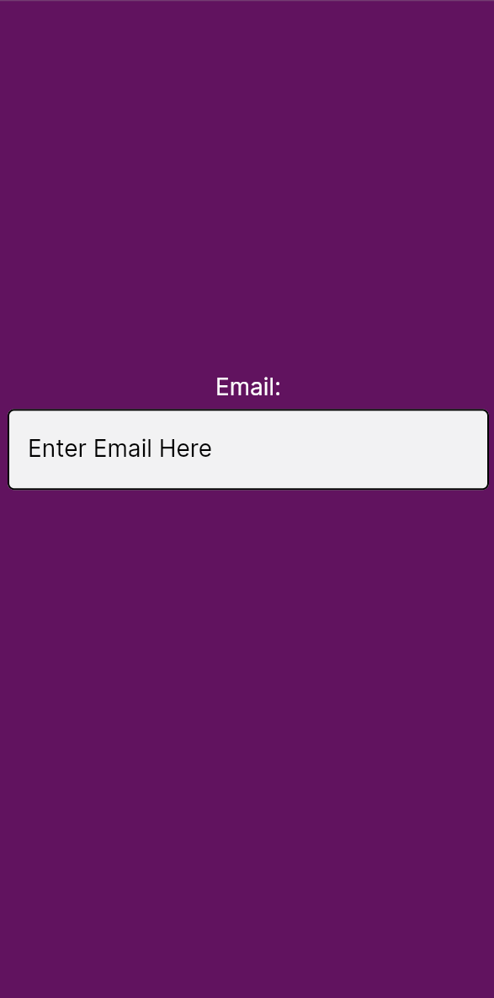 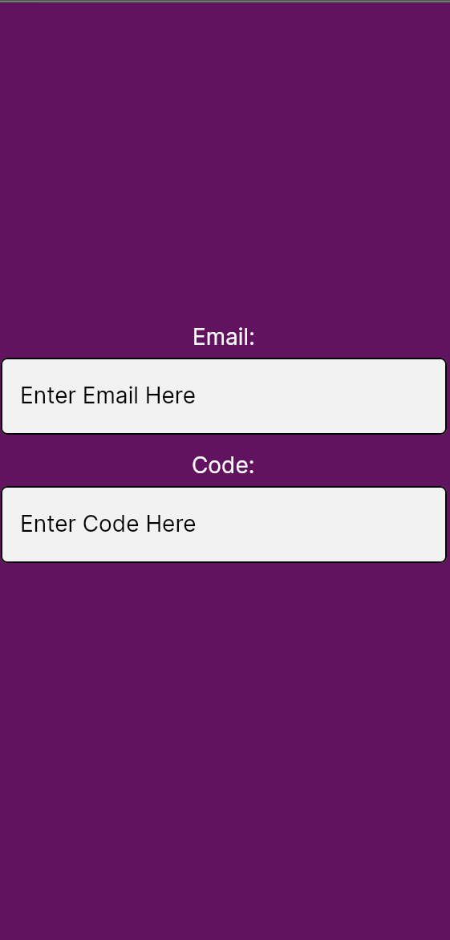

### Main Screen

The main screen will be divided into three sections, the app bar at the top coloured in purple, the navigation bar at the bottom, and the content of the current screen in the middle.

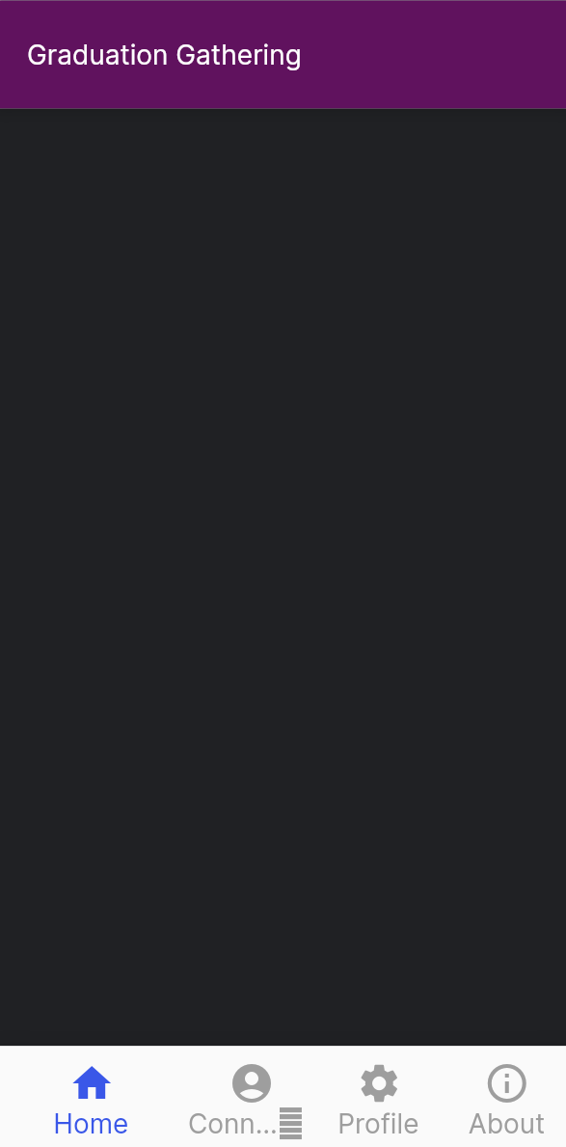

In this case since the current screen is the home screen which contains a Map at the centre which cannot be replicated in Flutter Viz, this Map has been left blank. The map displayed will be an Open Street Map with markers and shapes overlaid.

### Connections

The connections screen should allow users to manage who has permission to see them, and who they have permission to see. To allow this, the connections screen will first display a list of all the users that this user either has permission to see, or that has permission to see this user. I will also supply buttons next to each user in the list so the given user can manage whether they should have permission or not.

I will also have a button at the top that takes the user to a screen that will let them request permission to locate other users. This screen will then allow users to search for other users and provide a button to request permission from them.

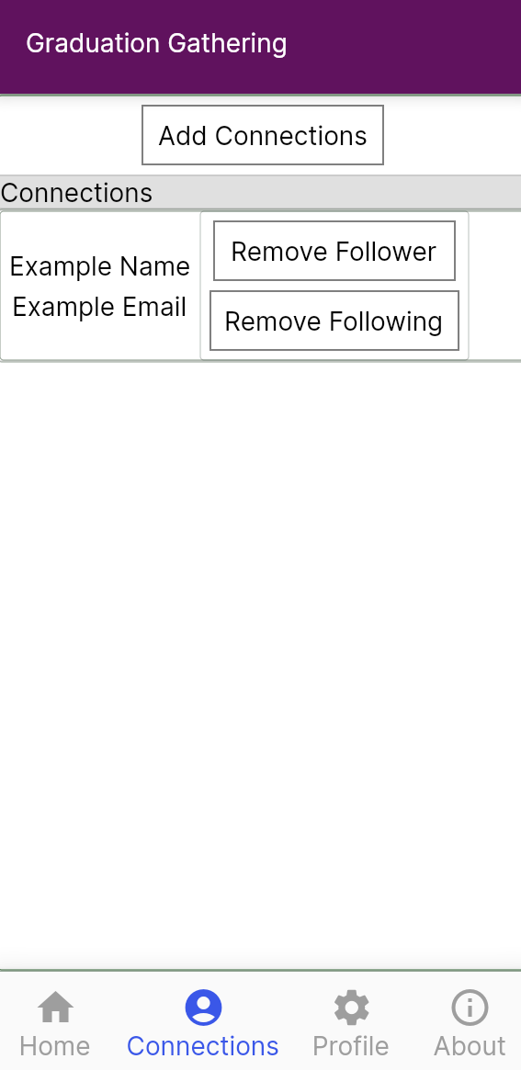 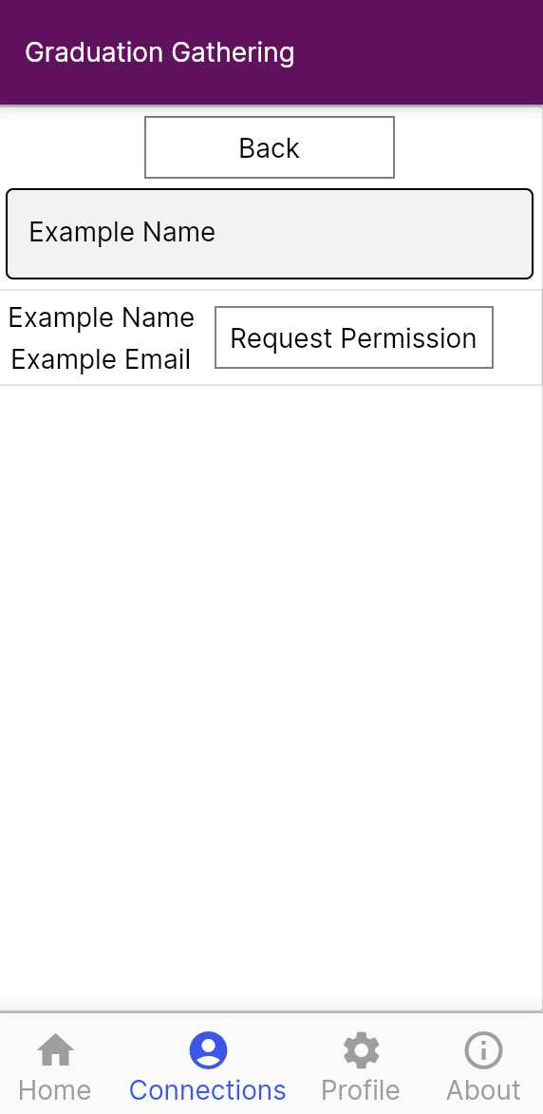

### Profile

The profile screen should allow users to enter their name, faculty, school, and if applicable, course. It should also allow users to select which graduation zones they want to be seen in.

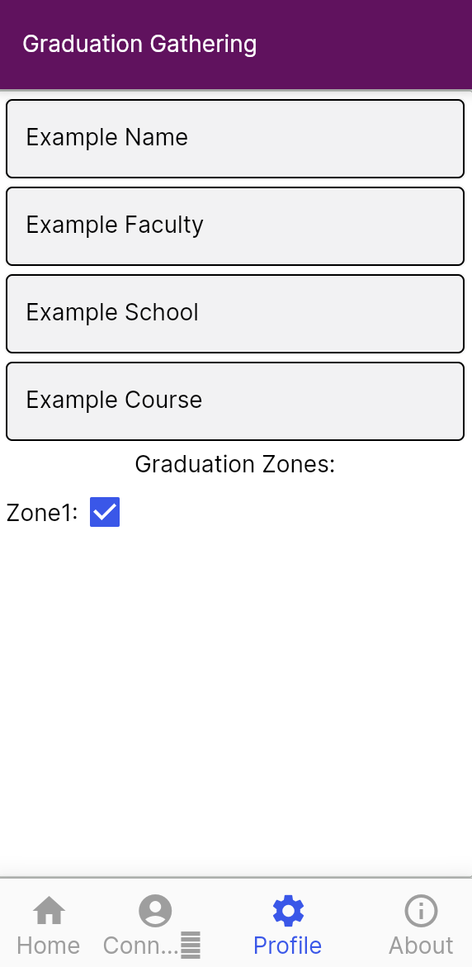

## Architectural Design

The architecture can be split into 2 parts, the front-end and back-end. The back-end will be created out of a set of AWS lambda methods that will retrieve data from the database and set data into the database. All of these lambda methods, except the login methods, will be authenticated with a JWT(json web token) that will be generated by the server when the user logs in. The use of JWTs will allow all requests sent to the server to be associated with the user that sent the request.

The front-end design will be based around the different screens as there will not be a significant part of the front end that is not directly working with the UI. The UI will be built by embedding screens(widgets) within other screens(widgets), this is standard for Flutter. However, for this project, all functionality will be to its relevant screen, and if its needed by multiple screens, then it is attached to the closest parent screen to both of the child screens.

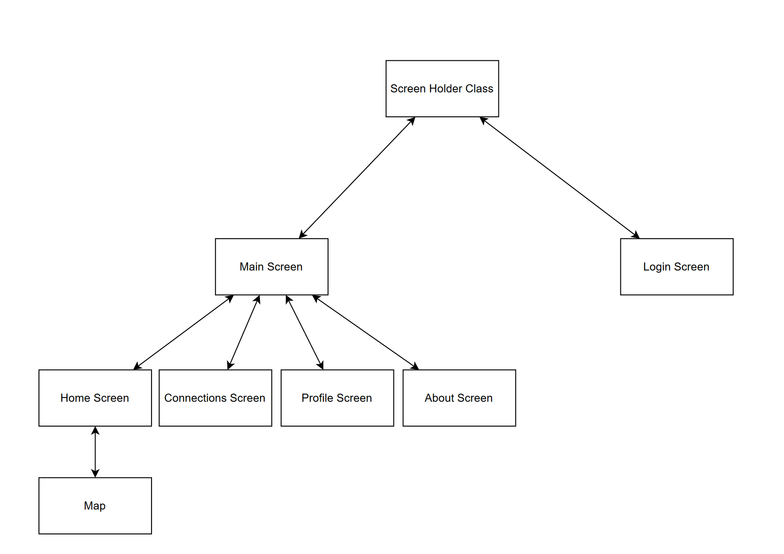

## Database

The database is a MySQL database hosted on AWS using the RDS. AWS was chosen for this project as they have a very reliable database service that I have used before whilst also allowing for back-end processing to be written and deployed efficiently using AWS lambda.

I used https://app.diagrams.net/ to create an entity relationship diagram for my database. There are five parts of this schema, 4 of which are linked by the user table, the location permission part, the course part, the graduation zones part, and finally the user table itself. The one other part is the Graduation Dates table which is on its own an just holds the days on which graduation ceremonies are held.

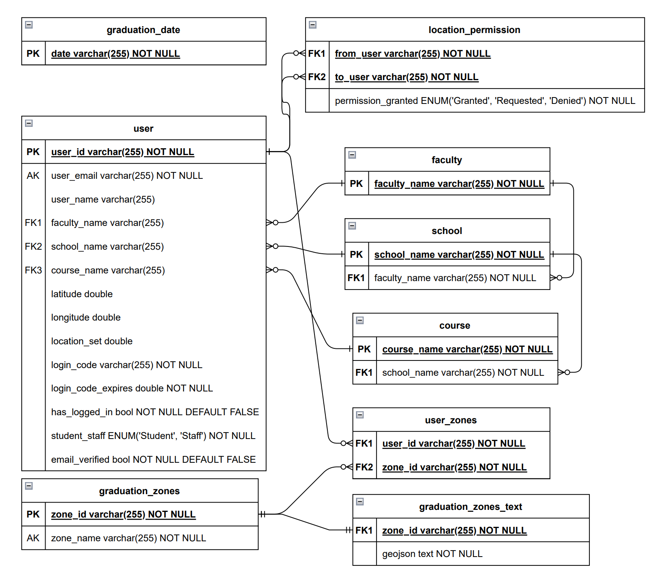

### User Table

This table stores everything directly related to a user, which includes data such as their name and email address, but also their course, their last known latitude and longitude along with the time when that location was set, as well as their login code. When each user first enters their email address a unique user id is generated for them and that is set as the primary key in the database so that in the future if support for changing your email address is desired then it will be more feasible to add.

The has_logged_in row and the email_verified are separate as has_logged_in is used to direct the app to take the user to their profile if they have never edited it before and so remains false until the profile has been edited, whilst email_verified is false until the user correctly enters the code which will log them in for the first time.

### Location Permissions

The location_permission table is used to give permission to see other users. When a user, let’s say User A, first asks for permission from another user, User B, a new entry gets added to the location_permission table where from_user is the user id of User A, to_user is the user id of user B, and permission_granted is set to Requested. Then when user B accepts the request, the permission_granted row is changed to Granted. This now allows for User A to see the location of User B, but not the other way around. If User B wants to see User A then they must request permission separately, at which point a new entry will be created in the location_permission table where from_user is the user id of User B, to_user is the user id of user A, and permission_granted is set to Requested.

This approach of creating separate entries in the location_permission table for when User A requests permission from User B and from the other way around allows for location permissions to be managed separately, as in it allows User A to see User B but not the other way around, whilst still keeping an efficient and easy to understand database design.

### Course

The faculty, school and course tables do not store any information about the users themselves. What these tables do store is the academic structure of the university, all the courses on offer, linked to which school they are in, and linking each school to which faculty they are in. This then allows the user table to efficiently store the faculty, school and course of the user by simply linking to these tables.

The advantage of this is that when a course, school or even faculty is removed from the University of Portsmouth, its entry into its table can simply be deleted and its presence in the entries of the users who have added it to their profile and easily be deleted as well by cascade.

### Graduation Zones

The actual geojsons for the graduation zones are stored in the graduation_zones_text table whilst the label for the zone is stored in the graduation_zones table. These are separate due the fact that the geojsons are too large to be indexed in a MySQL database, and so the solution to this problem is to store the zone id and label in a separate table that can then be indexed for fast retrieval. These zones are then linked to users using the user_zones table.

When a user saves to their profile that they want to appear in a given zone, then an entry in the user_zones table is created with both the users id and the zones id. When a user then saves that they no longer want to appear in a zone, that entry is then deleted. This allows for quick retrieval of which zones a user wants to appear in, not getting slowed down by the lack of indexing in the graduation_zones_text table.

# Development

This section outlines the development process, technologies and implementation. This explains both the big picture decisions of how to structure the code and the implementation of individual methods. All screen shots are of the code and UI as it is at the end of development.

## Overview of Technologies

The back-end is hosted on AWS utilising AWS lambda to provide server-side logic and AWS RDS to provide a database. AWS RDS was chosen as it is a fast reliable service that can be easily scaled to meet the needs of the application. AWS also allows for one free RDS instance and so I am able to use it for this project free of charge. The database is a MySQL database as it is reliable and easy to use, I also have previous experience writing SQL queries for MySQL databases. AWS Lambda was chosen as it is a serverless approach that allows for individual lambda methods to be created very quickly and efficiently. I also have experience creating lambda methods and I am able to use AWS Lambda free of charge up to 100,000 requests per month. Since 100,000 is far more requests than an individual would ever make, this allows for the development of Graduation Gathering to not occur any charge. The lambda methods have been written in Python as my previous experience with AWS Lambda was using Python.

The front-end of the application was written in Dart using the Flutter framework. Flutter allows for development for both iOS and Android and so only one front-end had to be written instead of two. I have previous experience with Flutter development for iOS and Android.

To render and interact with the map the OpenLayers JavaScript package has been used. This retrieves and displays an OpenStreetMap map. I have already built a Flutter application that uses OpenLayers and so I will be reusing that code for this project. The reuse of this code saves time in both the implementation of the code and the testing.

Git has been used throughout the development of this project to back up the progress made and to allow for version control. In order to properly allow for version control the branch features of Git have been used. GitHub and GitHub Desktop have been used to make using Git easier and so more efficient.

To manually test and debug the front-end software Android emulators were used provided by Android Studio.

## Sprint 1 – Project Start Up

The first sprint I undertook focused on creating an initial framework from which all other sprints could be based upon. By this I mean making a start in each area of the project and integrating each of the main technologies, packages and tools.

### Task 1 – Flutter Project Creation

The first task was to create the Flutter project and set up the initial UI. The initial UI is the base for the main screen of the application, the screen that you see once logged in. It has a bar at the top displaying the words “Graduation Gathering”, a navigation bar at the bottom that allows you to select which screen you would like to look at, and finally a space in the middle of the screen to display the content of the screen selected by the navigation bar.

### Task 2 – Navigation Bar

The next task was to add the logic for the navigation bar so that screens can be added efficiently in the future. This is handled in the file navigation_bar_items.dart through the class NavigationBarItems and the enum NavigationBarItemEnum. To add a new screen to the navigation bar first you add an enum for the screen that will hold the icon and name of the screen to be displayed on the navigation bar, as well as an integer that will hold the position in the navigation bar that the screen should be.

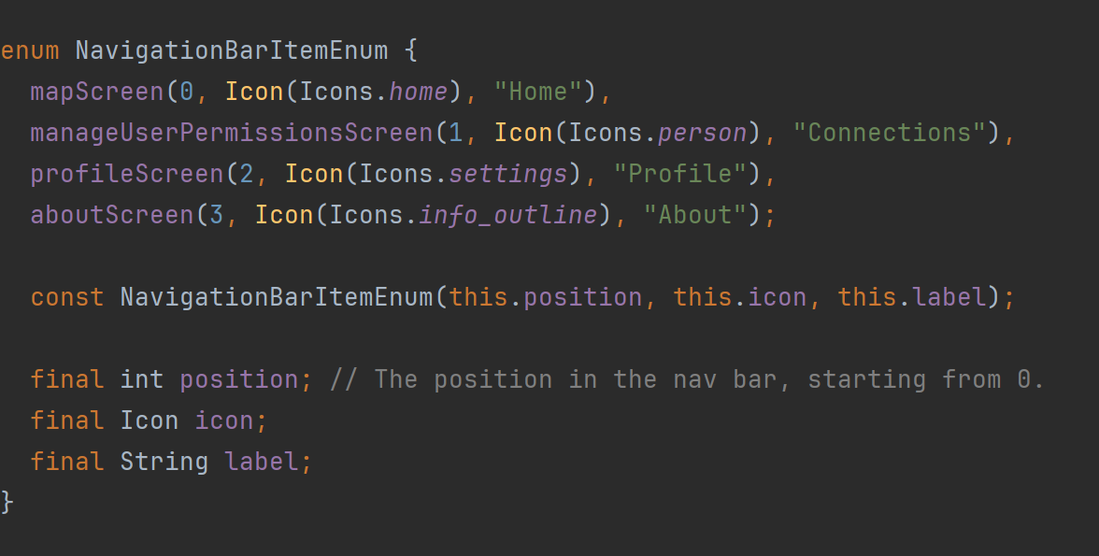

After adding the screen as an enum you then instantiate the screen within the constructor of NavigationBarItems and add the screen to the list of screens as shown below. The main screen then gets all the child screens from the NavigationBarItems class and automatically adds them to the navigation bar and makes it so that the screen appears when the user clicks on the icon for the screen from the navigation bar. This setup makes it very efficient to add new screens and allows the screens to be managed easily.

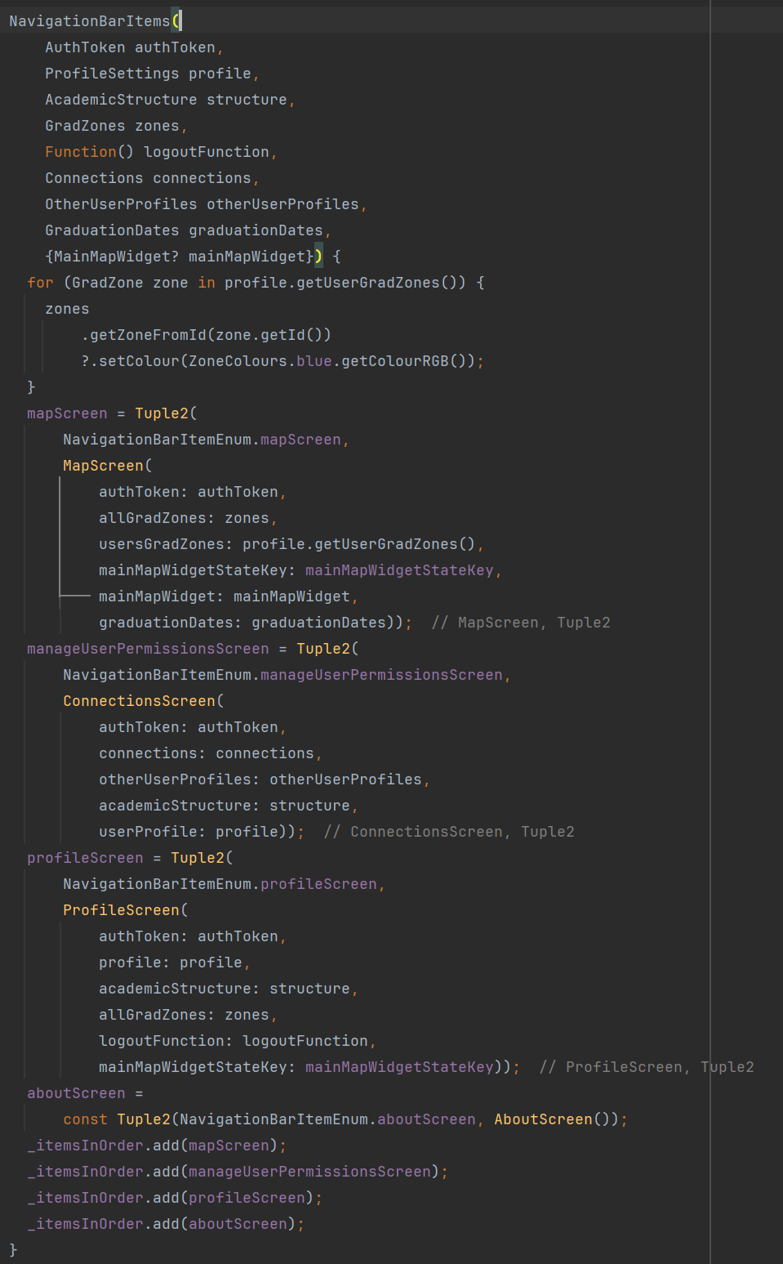

### Task 3 – Map Screen Creation

After this, the next task was to add the map screen to the application. I reused code I wrote for an earlier project here and so this was done quickly and efficiently. The MapScreen class creates the map widget and allows for other widgets to appear in the map screen apart from just the map.

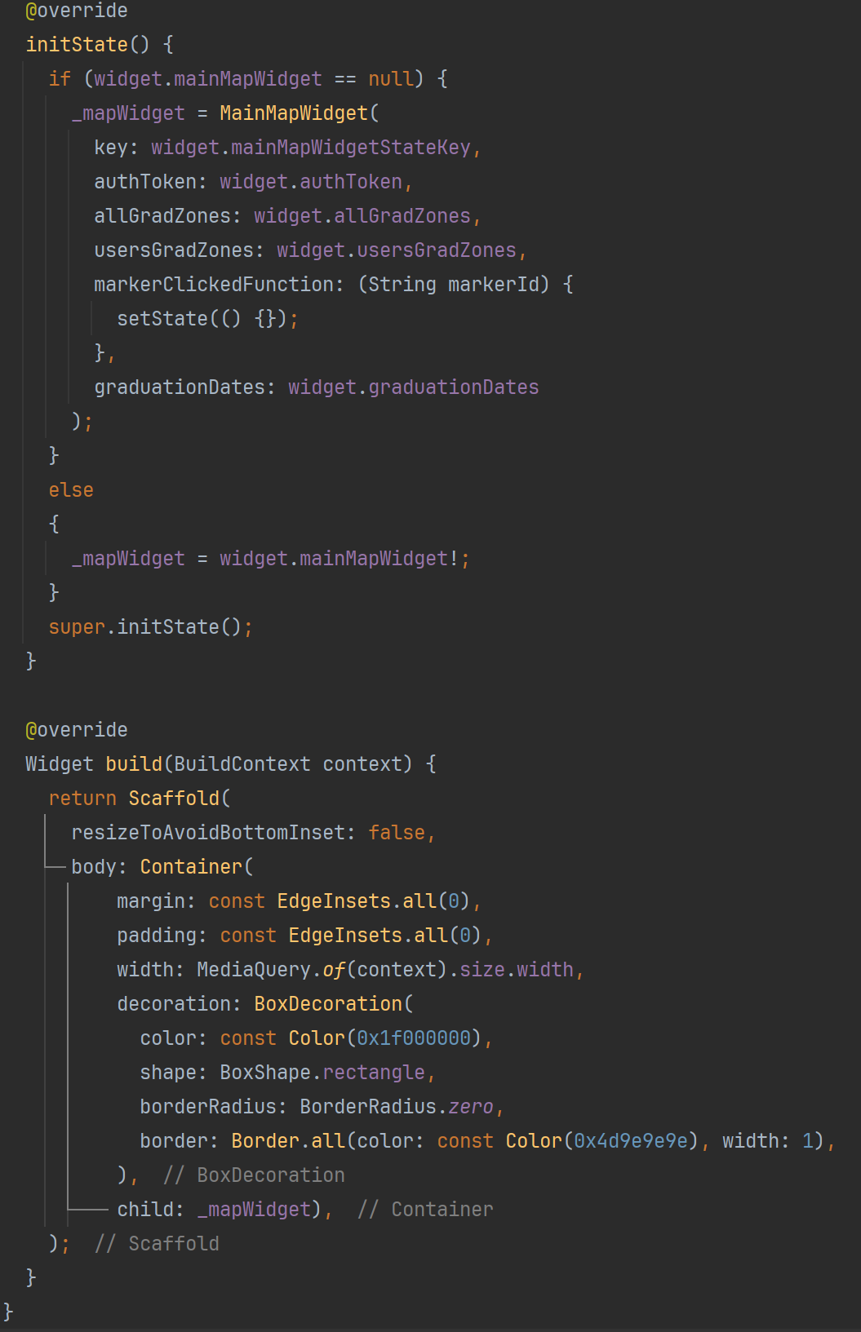

The MapWidget abstract class is used to interact with the OpenLayers JavaScript library. MapWidget loads the html file map.html which contains the JavaScript to interact with the OpenLayers API.

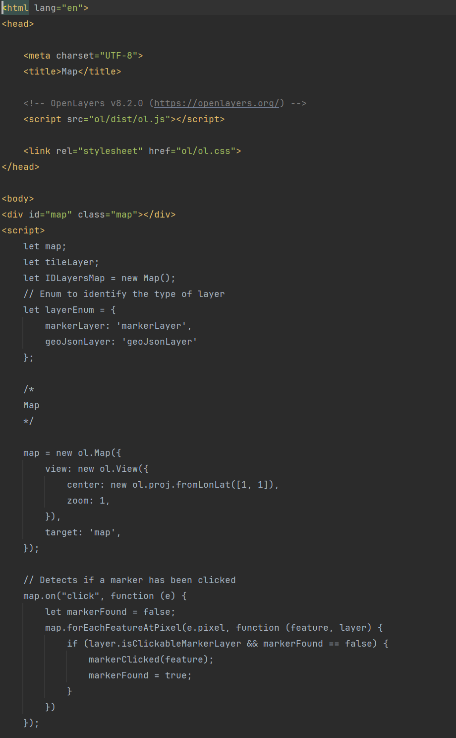

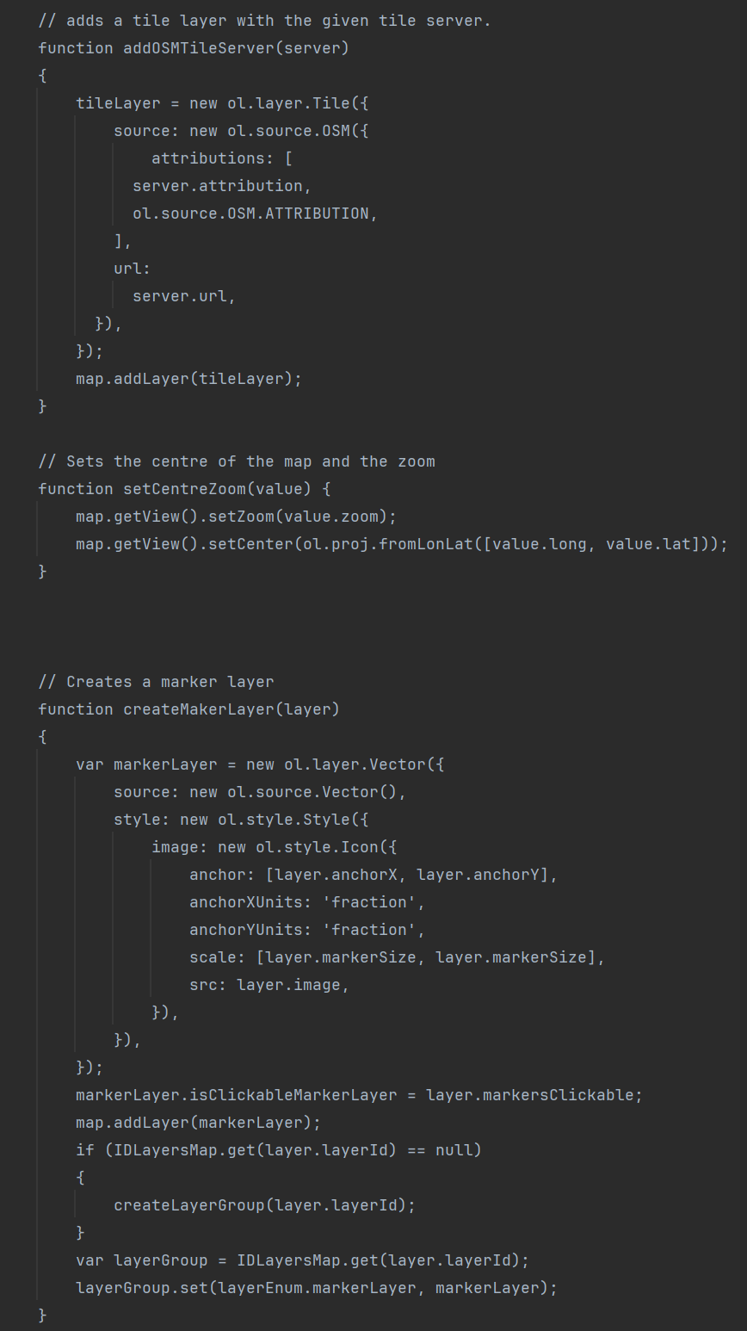

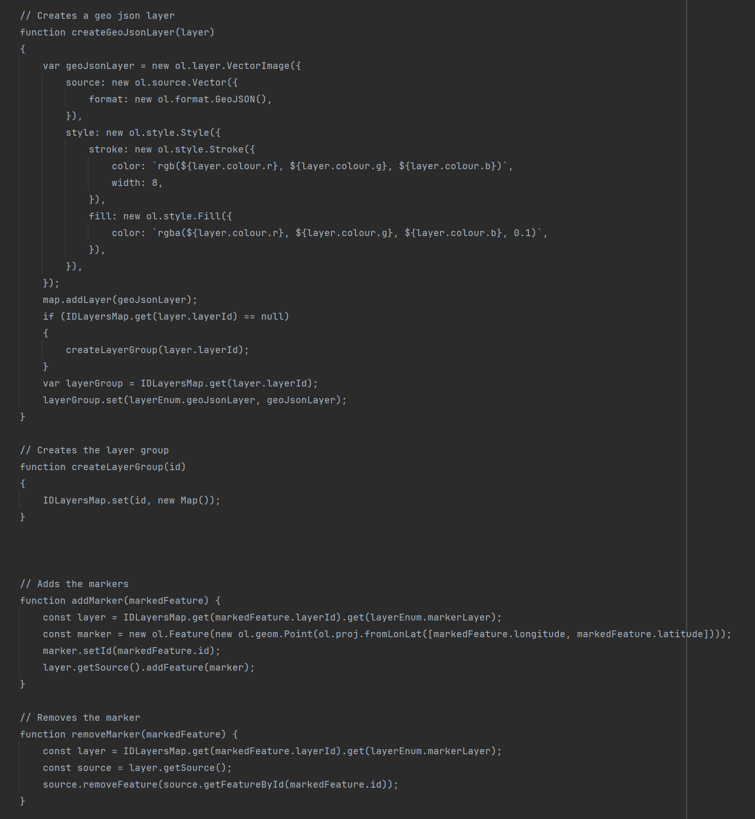

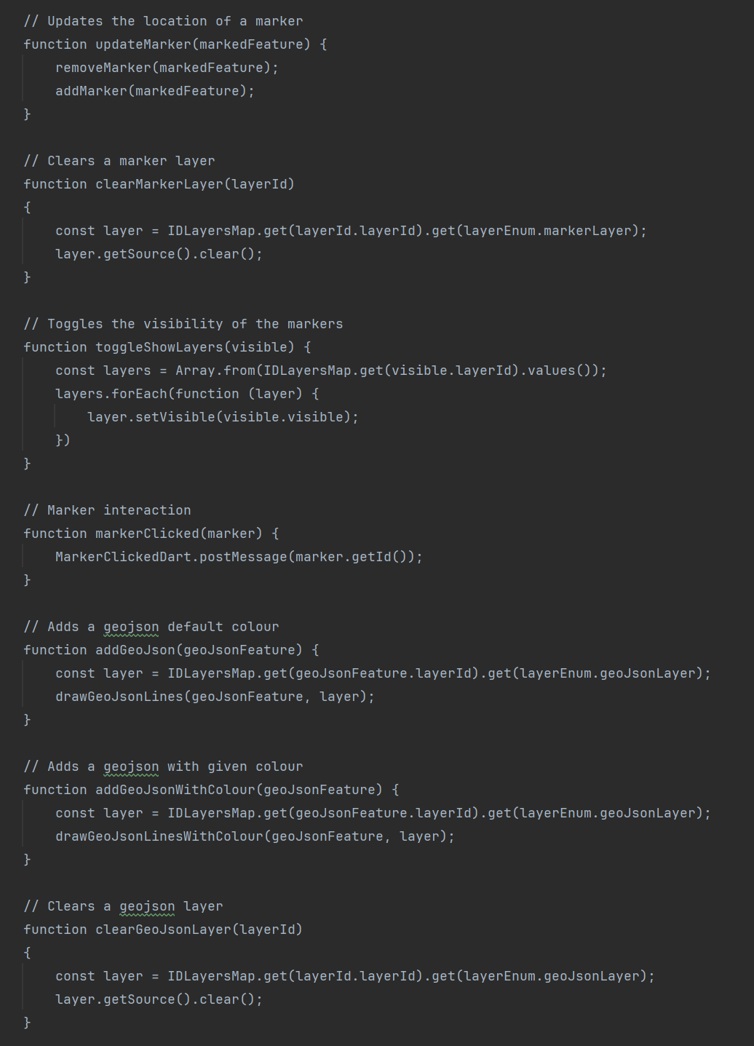

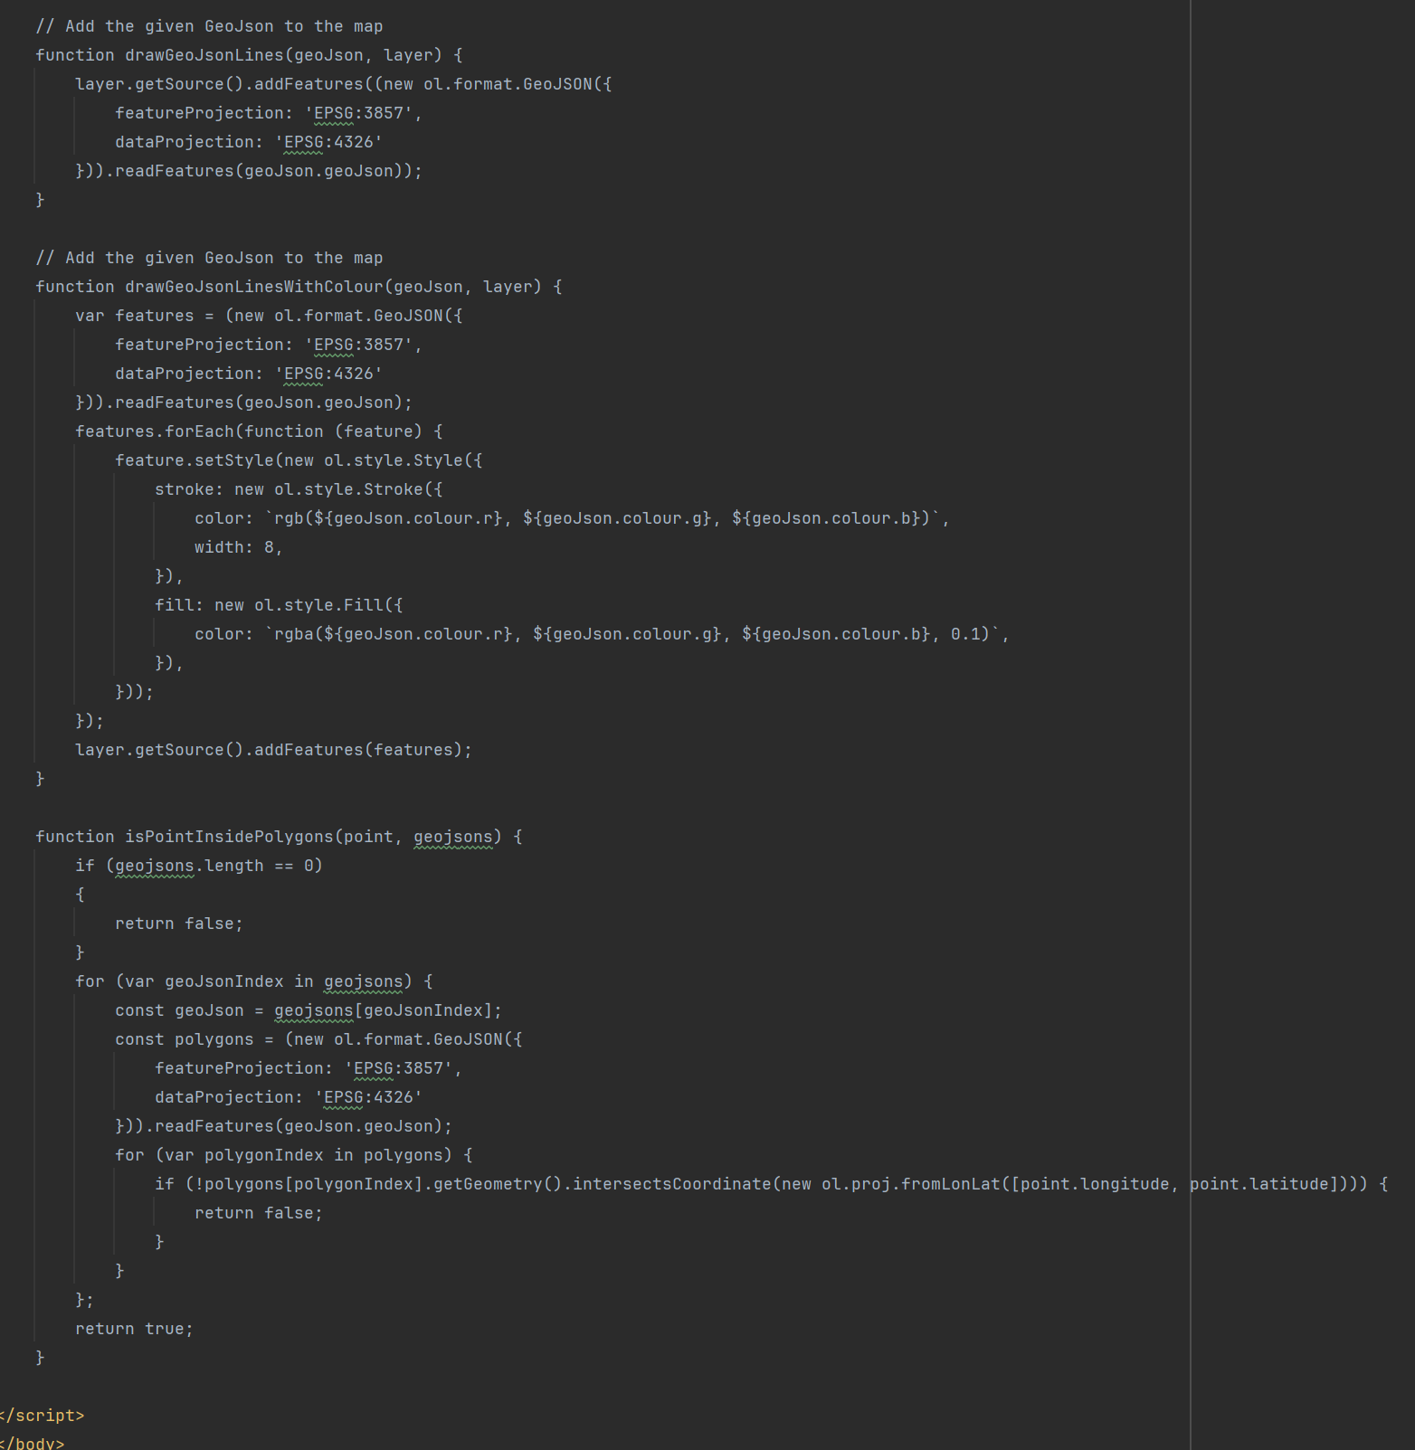

To render a map on the screen a child class must be created that extends MapWidget, this allows for multiple maps to be created within the application that might have different requirements, this is a feature that is not used within Graduation Gathering but was used in the project that this class was originally written for. For Graduation Gathering, the child class used to create the map is MainMapWidget. Whilst MapWidget, MainMapWidget and the html file called map.html were all originally used for a different project, they have been edited to better serve their purpose within Graduation Gathering.

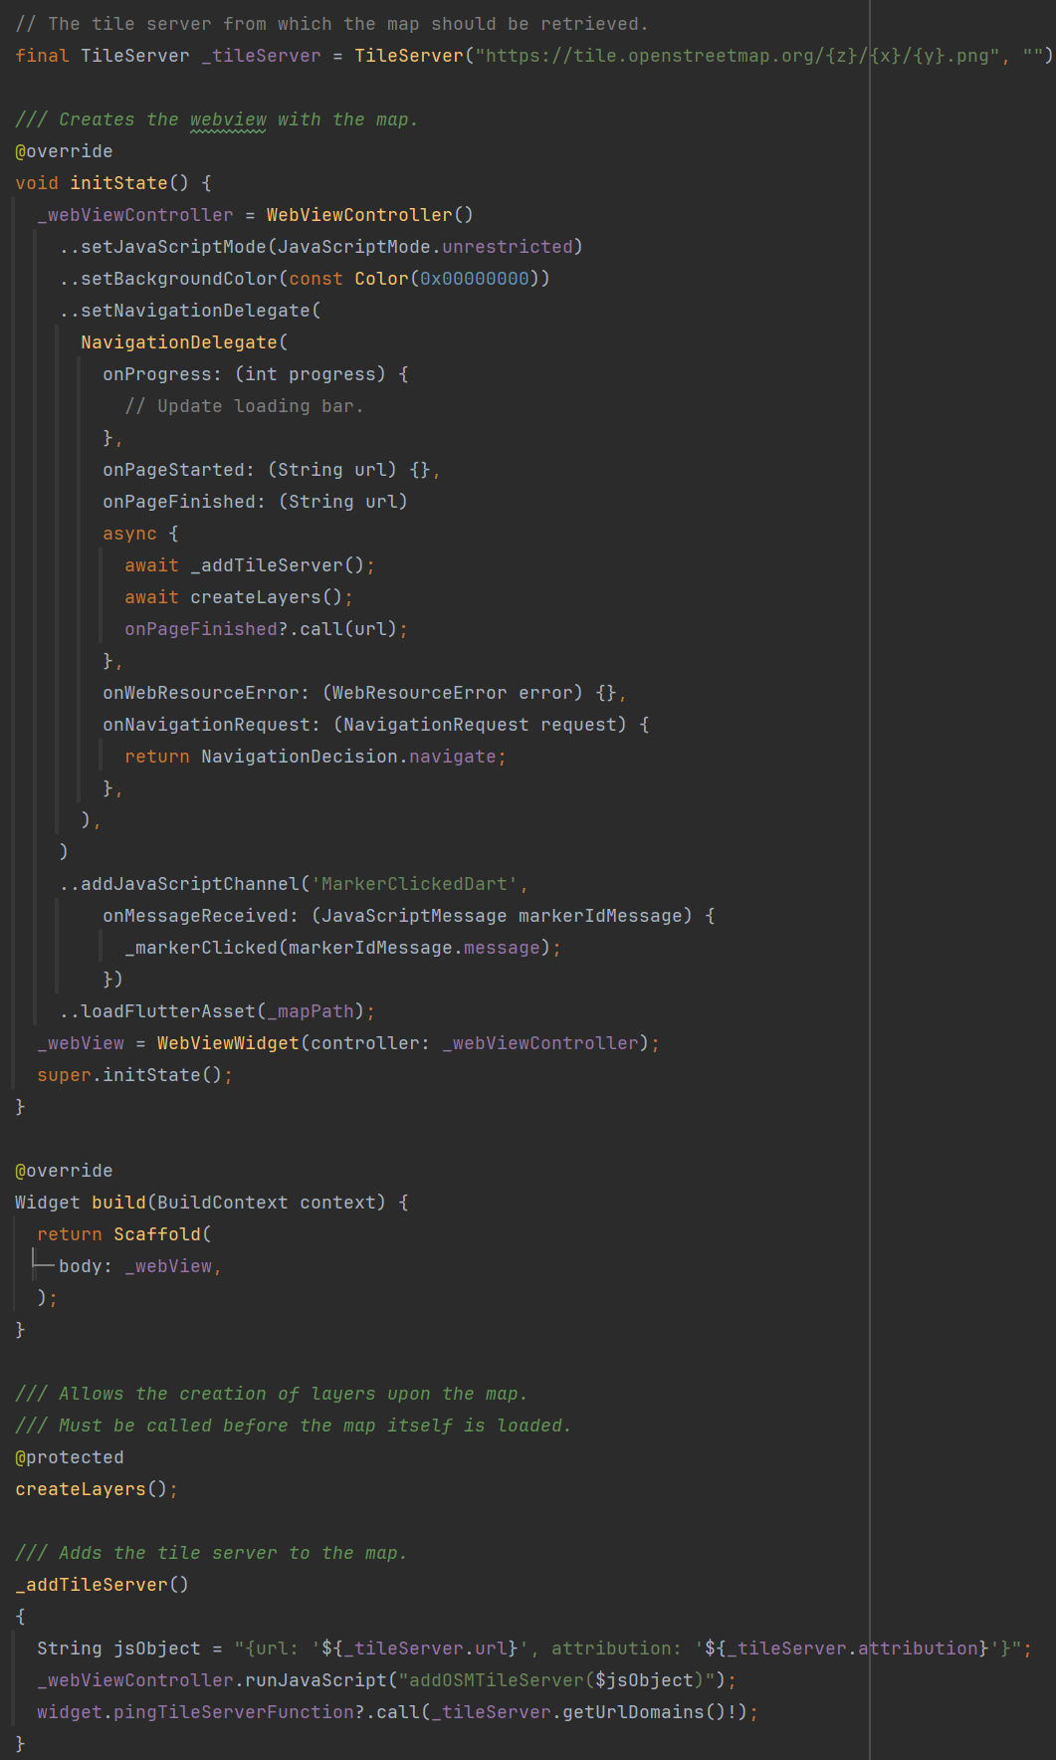

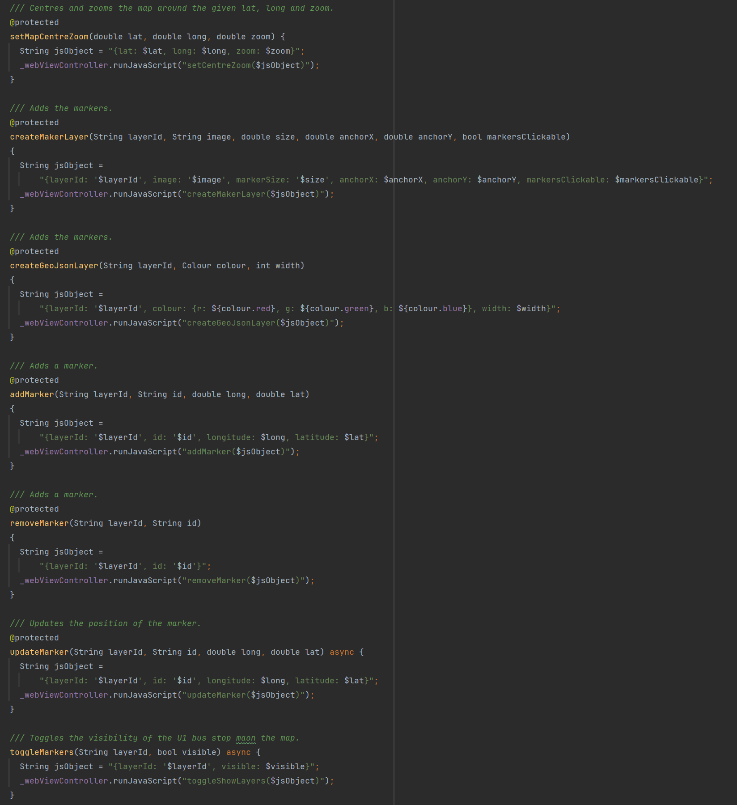

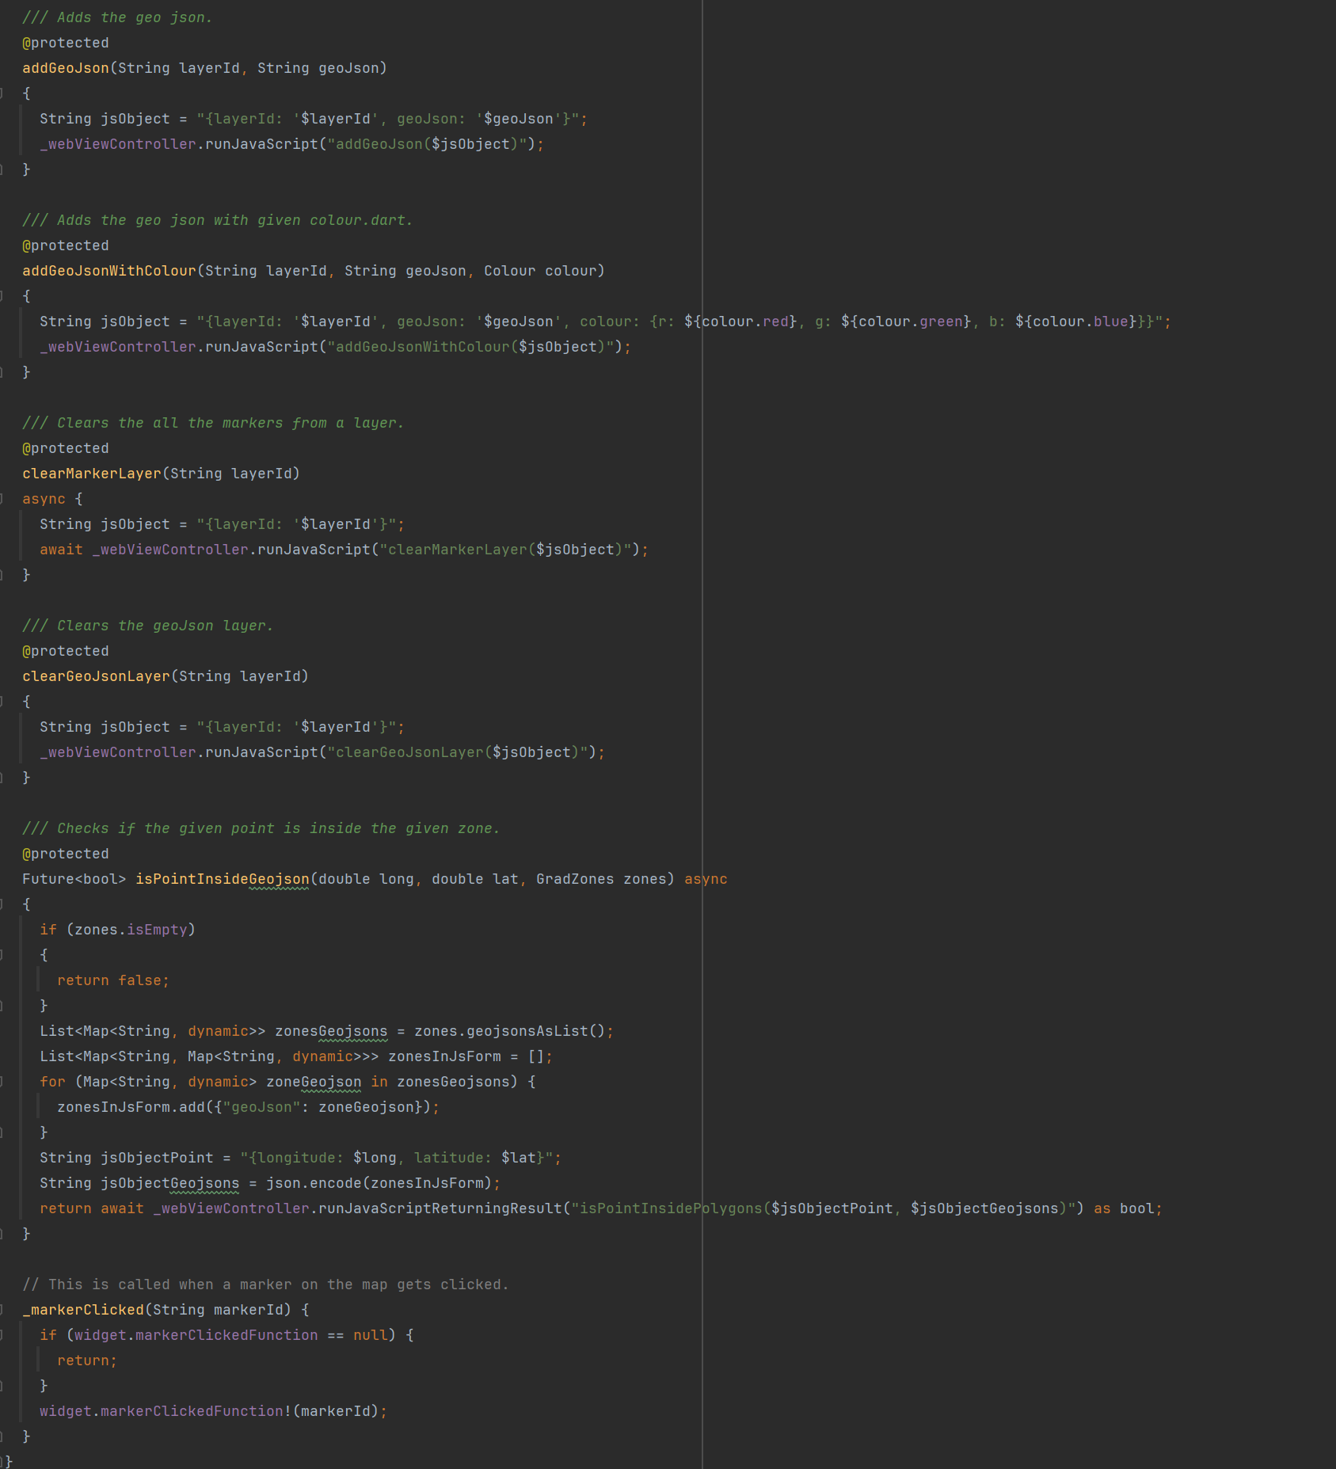

All communication between Dart and JavaScript is done within the MapWidget class, MainMapWidget only calls methods from MapWidget. This encapsulation simplifies the process of interacting with the map from the perspective of MainMapWidget and so makes it easier to add additional features.

The map is interacted with by adding layers that are rendered on top of the map, markers and shapes can then be added to these layers. To add a layer from the MainMapWidget class, you add a line to the createLayers() which calls either createMarkerLayer or createGeoJsonLayer from MapWidget. You must specify an ID for this layer that must be used whenever you want to interact with the layer later on. The layer ID’s on the Flutter side are stored in the MapDataId enum.

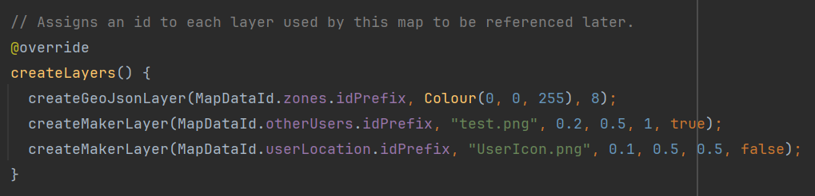

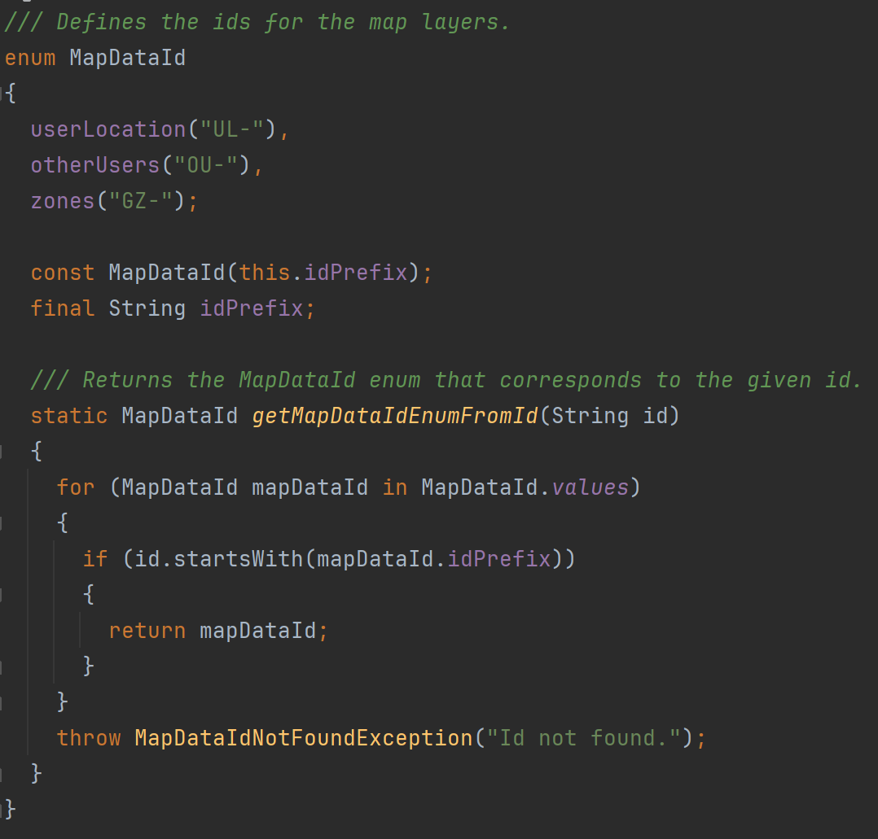

The user’s location is shown on the map through a marker. This marker is by adding a callback to the LocationHandler class. Whenever LocationHandler gets an update on users location, it then calls the method given to it by MainMapWidget. This method also sends a request to the server to update the user’s location for the other users of the app.

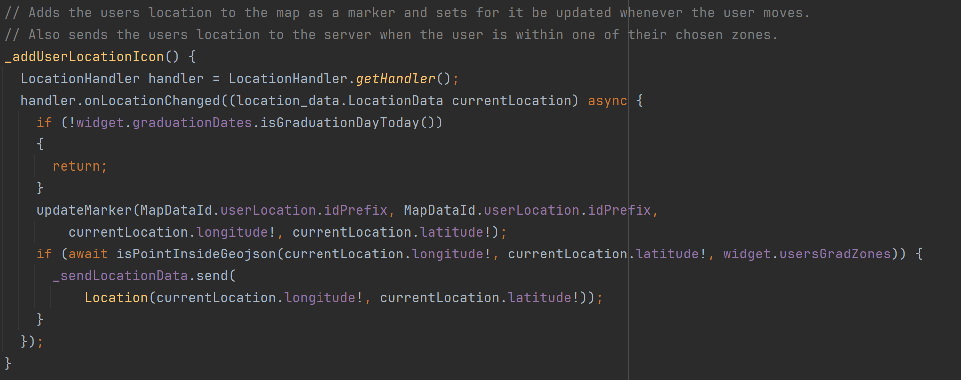

The locations of the other users that the current user has permission to see is updated by setting a repeated timer which fires every 10 seconds. It sends a request to the server asking for the other users locations and then loops through them adding each one to the map as a marker.

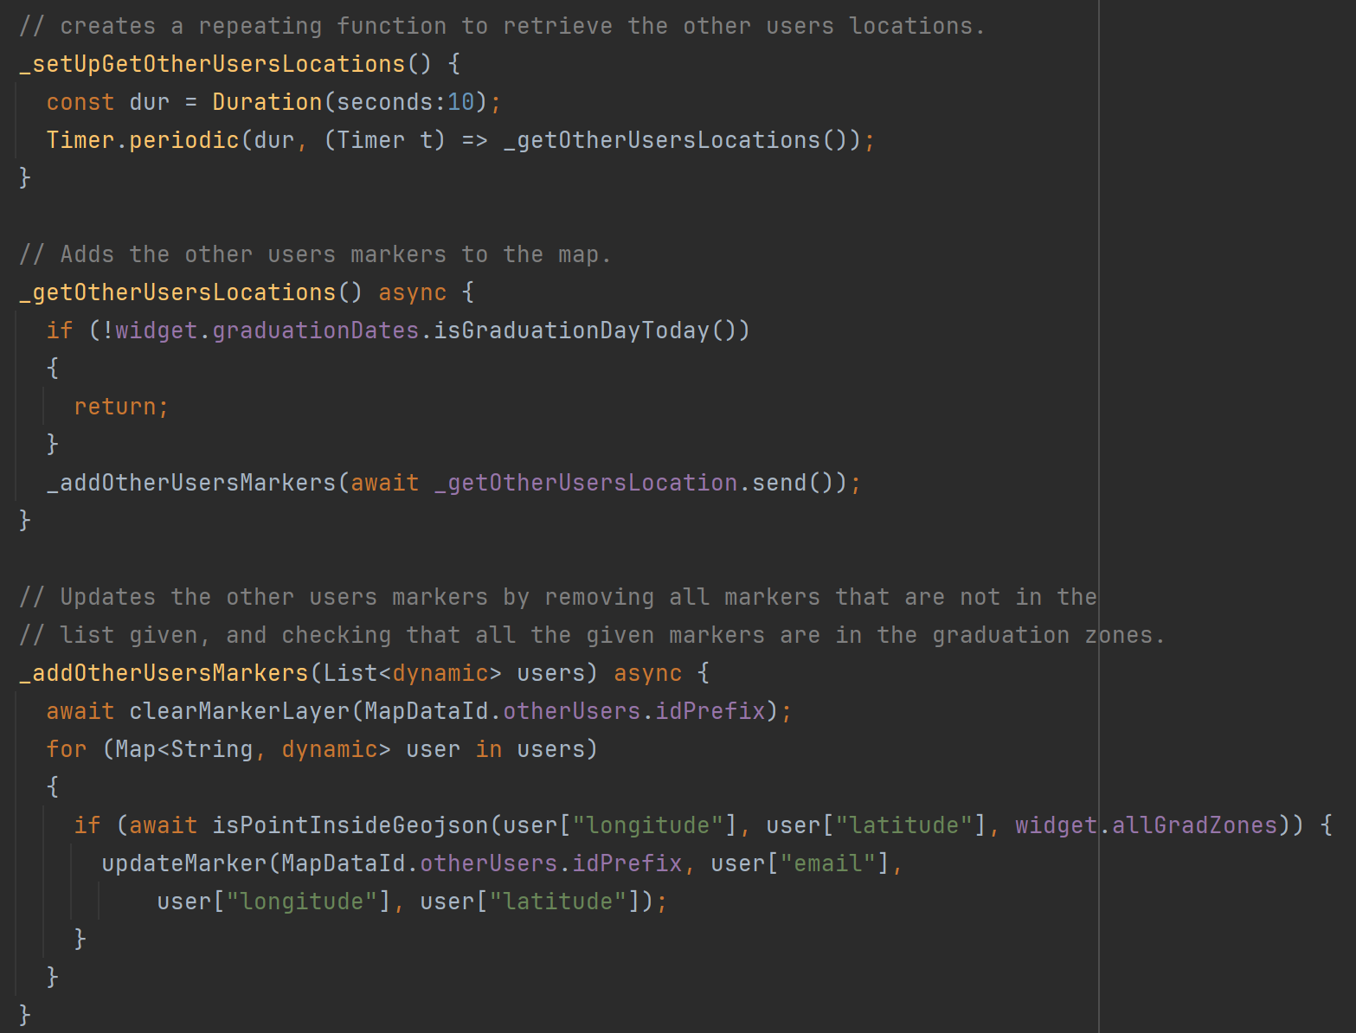

### Task 4 – Create Server and Framework For Calling the Servers Endpoints

Here I created the AWS RDS instance and the initial database schema. I also created initial AWS lambda methods to test the interaction with the database. These Lambda Methods are then exposed using AWS API Gateway.

The lambda method CreateAndAddToDatabase was created to manage the database schema as well as insert any data I needed to directly into the database. This method is not exposed by the API Gateway and can only be accessed using the AWS management console.

A blueprint for adding tables was created, for example see the SQL for the faculty table below.



Data could also be added directly to the database as shown below for the faculty table.



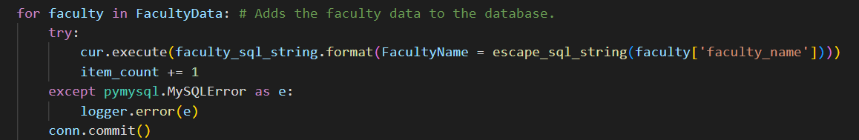

All lambda methods that access the database and interact with the database by giving it strings generated by the user contain a method to clean the string so that is cannot be exploited by these users through SQL injection attacks.

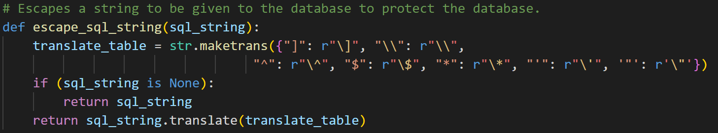

The main part of this task was to create a framework in Flutter for accessing the lambda methods in the server.

The design that I settled on is the SendRequest class which stores the server URL and has methods to send both GET and POST requests to the server. The way the system works is that, if you have an endpoint you want the Flutter app to reach, you create a child class of Send Request and in the getRoute() method that you must create, you return the route with the server to the endpoint that you want to hit. Then you create a method within this class that calls either post or get within SendRequest to actually send the request to the endpoint at the given route with the server. See below both SendRequest and SendLocationData as an example of how to extend SendRequest to hit a specific endpoint.

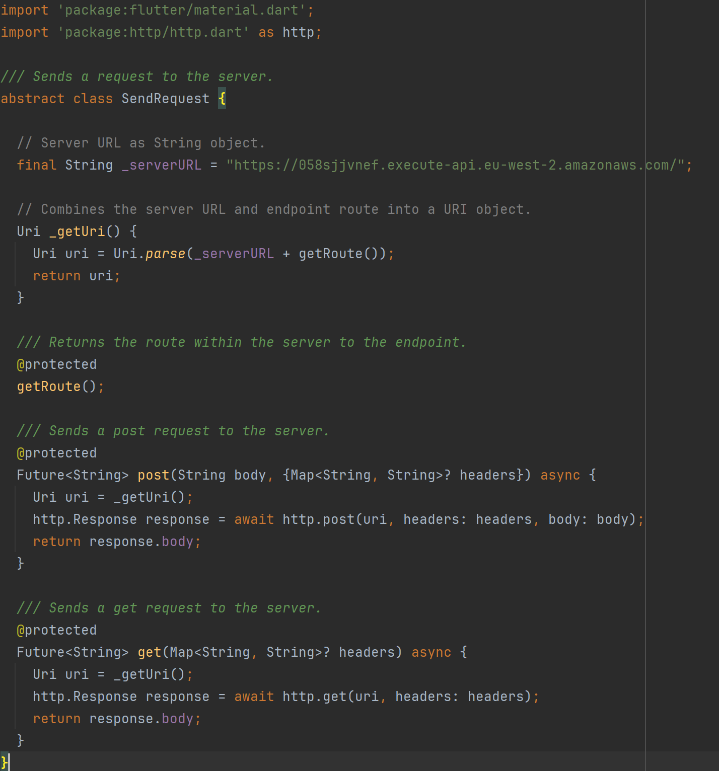

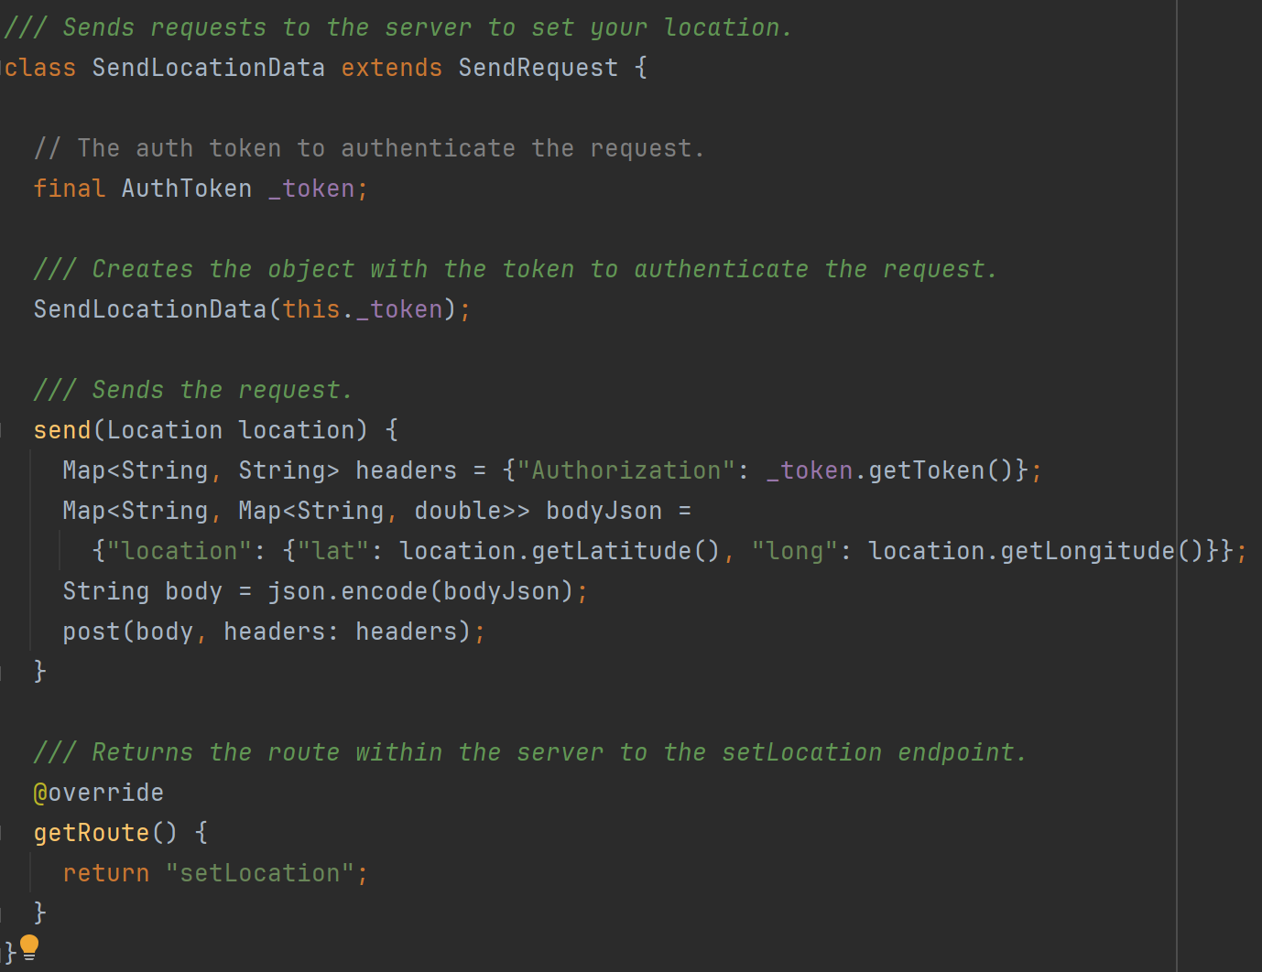

### Task 5 – Login and Authentication

To secure the server from unauthorised access, JWTs (Json Web Tokens) are used to authenticate every request to the server that is not used to login. AWS API Gateway makes it very easy to attach a lambda method that authenticates requests to be called before the exposed endpoint. Using this feature I created the Auth lambda method which is given a JWT and checks if the signature is valid (thus was created using the encryption key only the server has access to) and if the time on the token has not expired.

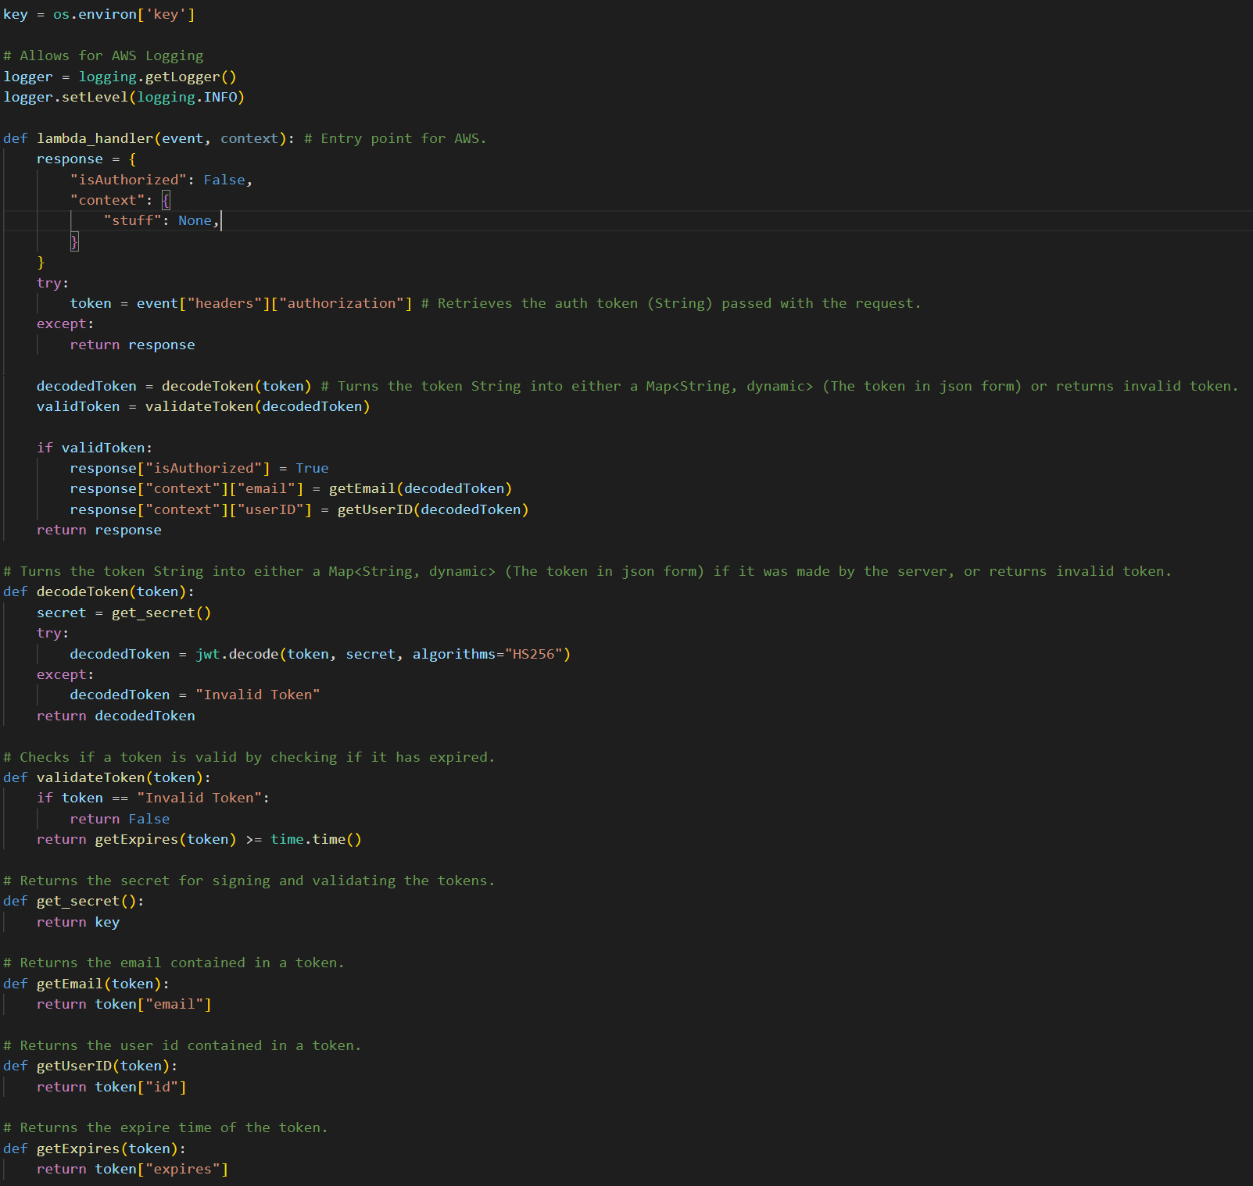

Users must also be able to obtain these tokens when they login. So I created a login screen in Flutter that allows users to enter their University of Portsmouth email. This screen is coloured in the light blue colour of the University of Portsmouth.

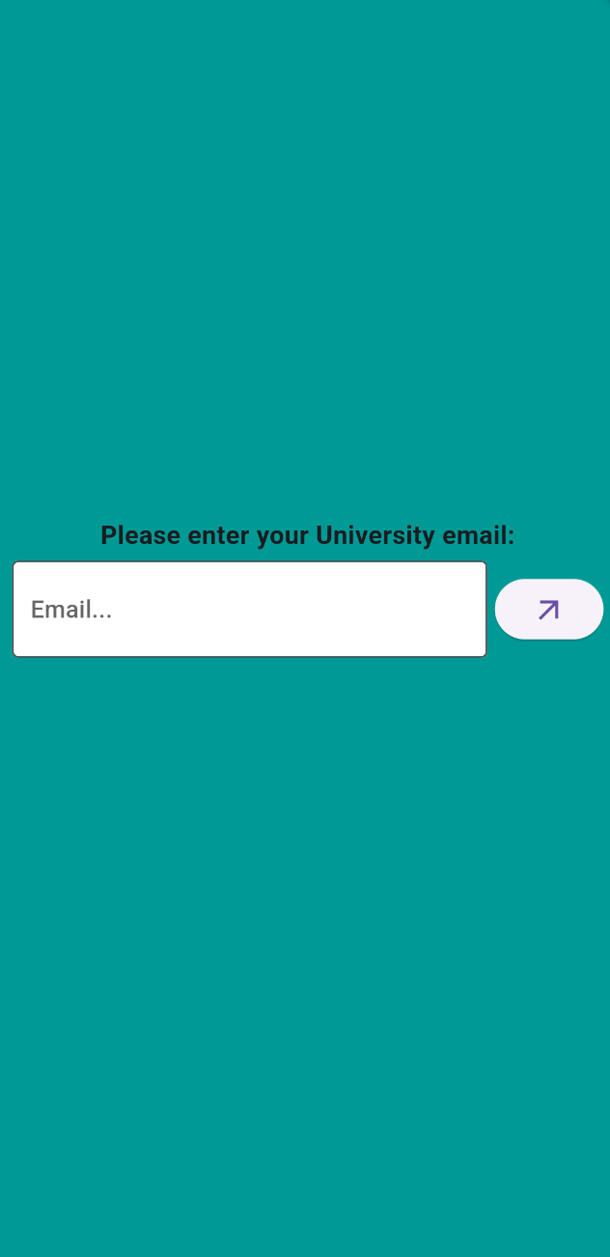

This email is parsed to check if it is a valid University of Portsmouth email. This is done in the ParseEmail class which uses a regular expression.

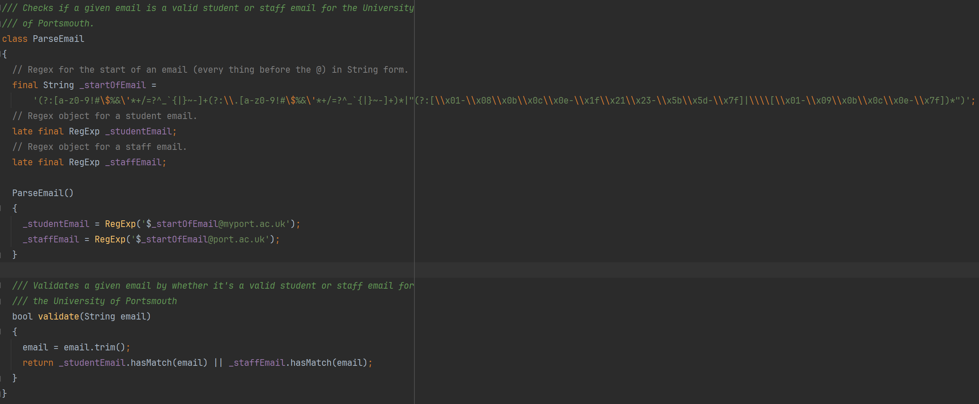

If the email fails the parse then the screen asks again for an email from the University of Portsmouth.

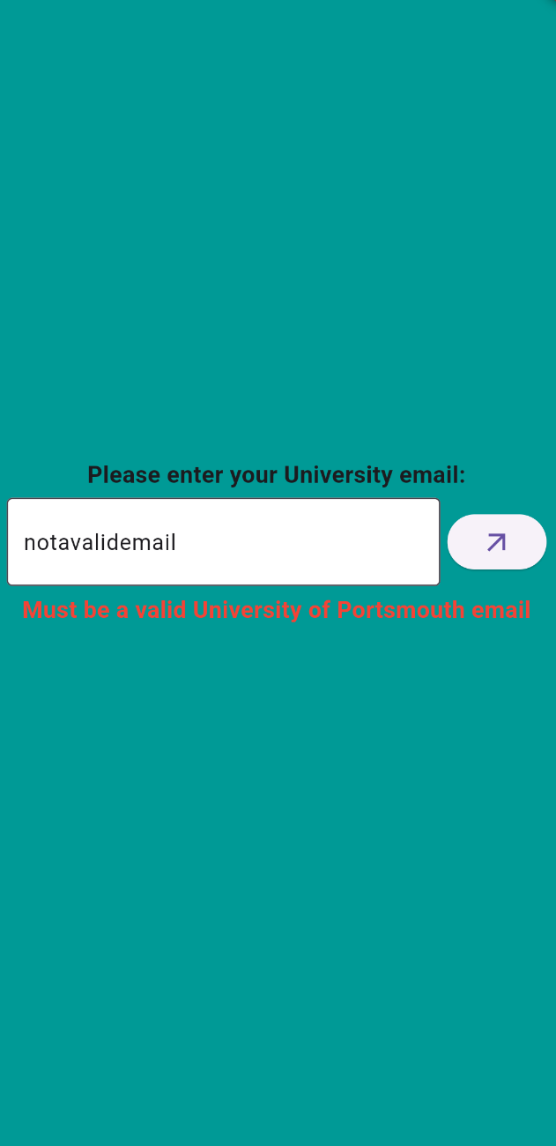

If the email passes the parse, then this email is then sent to the SendEmailCode lambda method. This lambda method checks if the email is a valid University of Portsmouth email, then checks if an account for this email exists in the database, if not then it creates an entry in the database for this email, then creates a login code for the account and saves that to the database, then sends a request to AWS SES (Simple Email Service) to send the login code in an email to the email address given.

To check if the email is valid, it uses the same regular expression as the Flutter App. This check is done on the client side to stop unnecessary requests being sent to the server, and its done on the server side for security so people cannot call the endpoint directly outside of the Flutter App and enter any email address they want.



Accounts are checked if they exist by trying to find the userID from the entry with the given email. This is the primary key in the database.

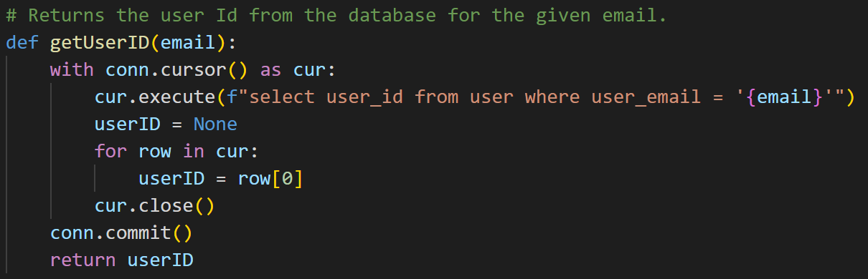

If no user ID is found then a new unique user ID is generated for this email. It is a code that starts with “US-“ short for user, and then is followed by 10 digits. It is guaranteed to be unique by then checking if the generated user ID already exists in the database, if it does then a new user ID is generated.

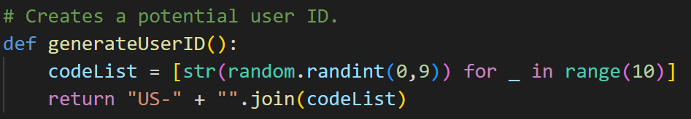

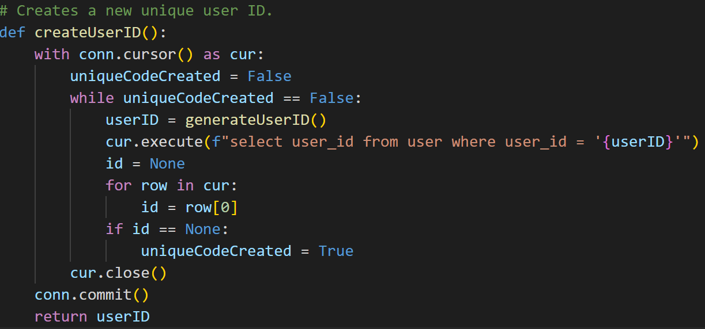

Next a login code is generated for the user, this is just a 5 digit number padded at the front with 0’s to always be 5 digits long.



The code is also given an expiration time as 5 minutes from the current time. This is done by getting the seconds since the Unix epoch and adding 5 minutes’ worth of seconds (5 * 60 = 300).



Then the code and expiration time is written to the database, if an account for this email does not exist then the user ID generated and the email are also written to the database.

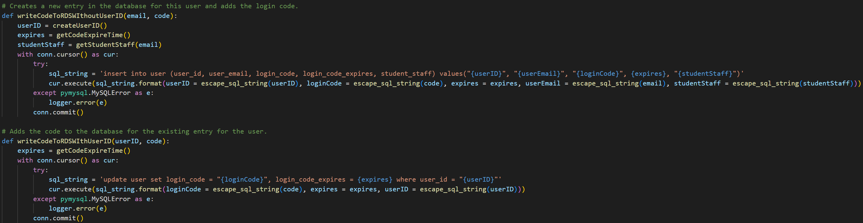

Finally an email is sent to the given email address with the code generated.

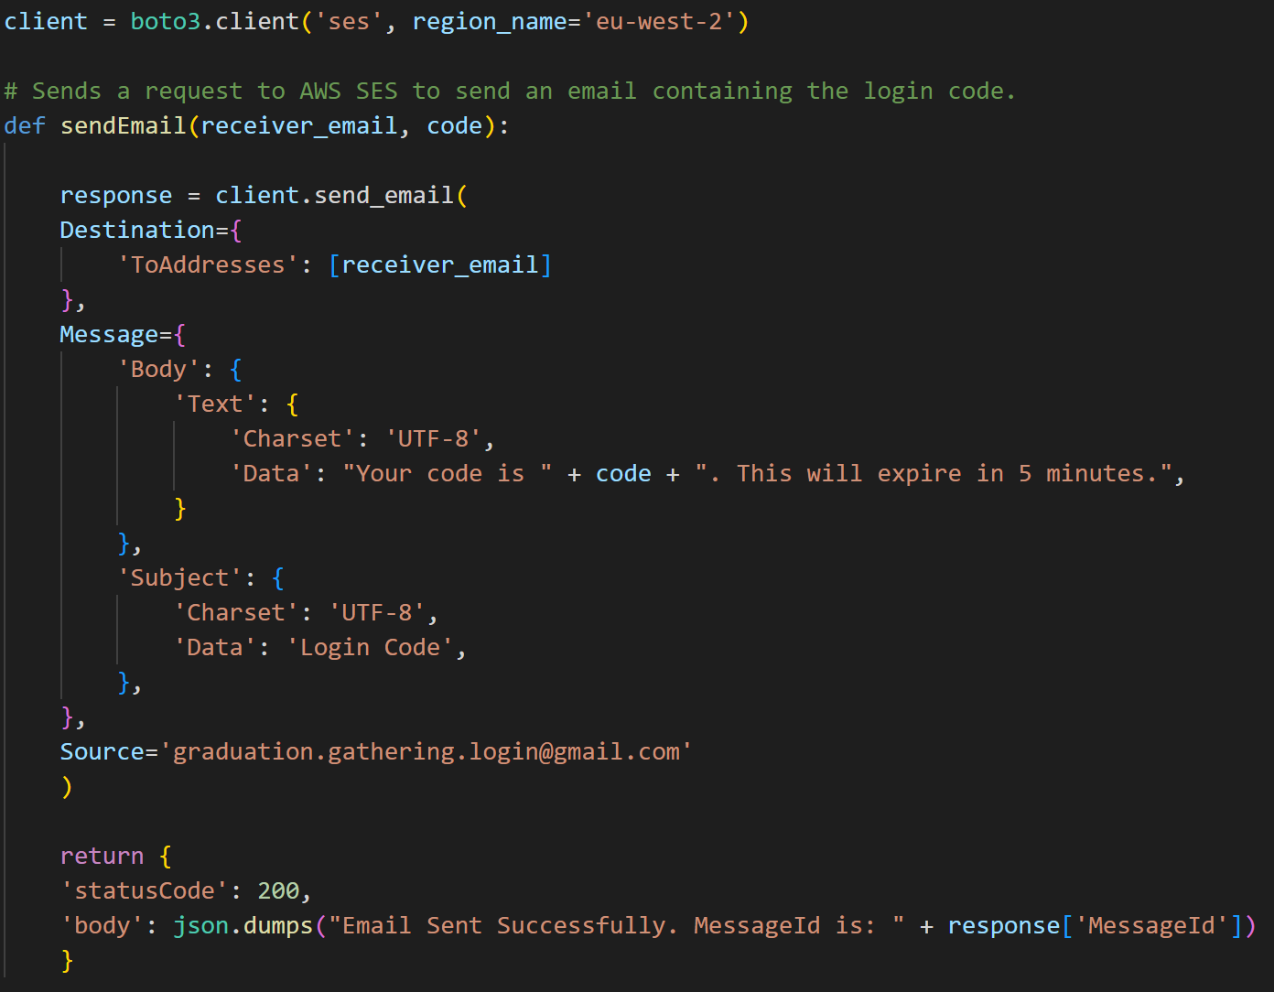

Now that an email has been entered, a code generated, and an email containing the code has been sent to the entered email, the user is asked to enter the code.

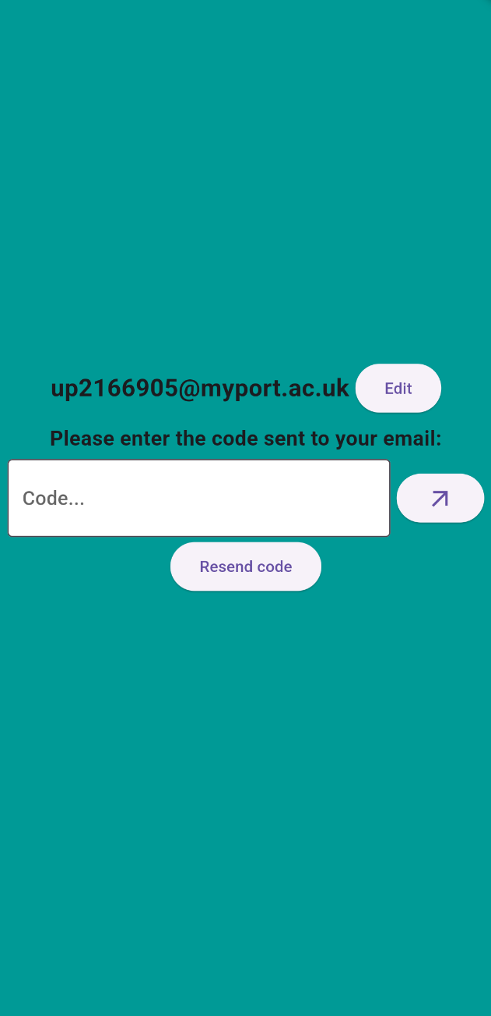

The code entered is then sent along with the email to the ValidateCode lambda method. This then verifies if the code has been entered by retrieving the login code and expiration time for the given email from the database.

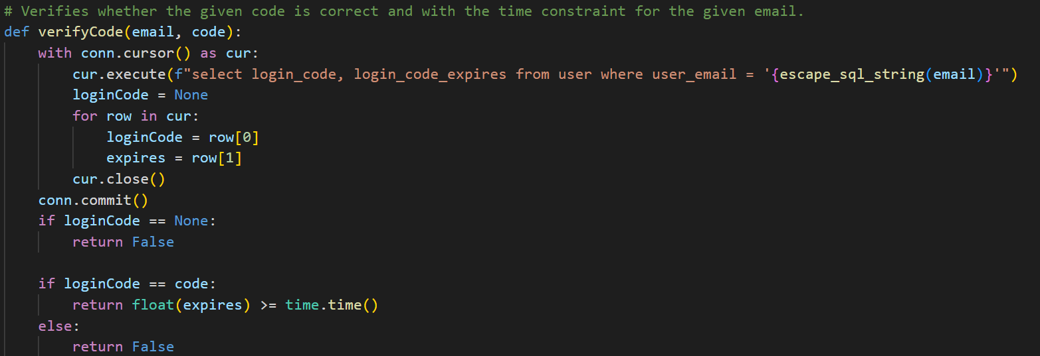

If the codes match and the time hasn’t expired then the user ID for that email is retrieved from the database and a JWT is generated using the user ID and email, and is signed using a key stored on the server. This JWT is also given an expiration date of 24 hours from its creation.

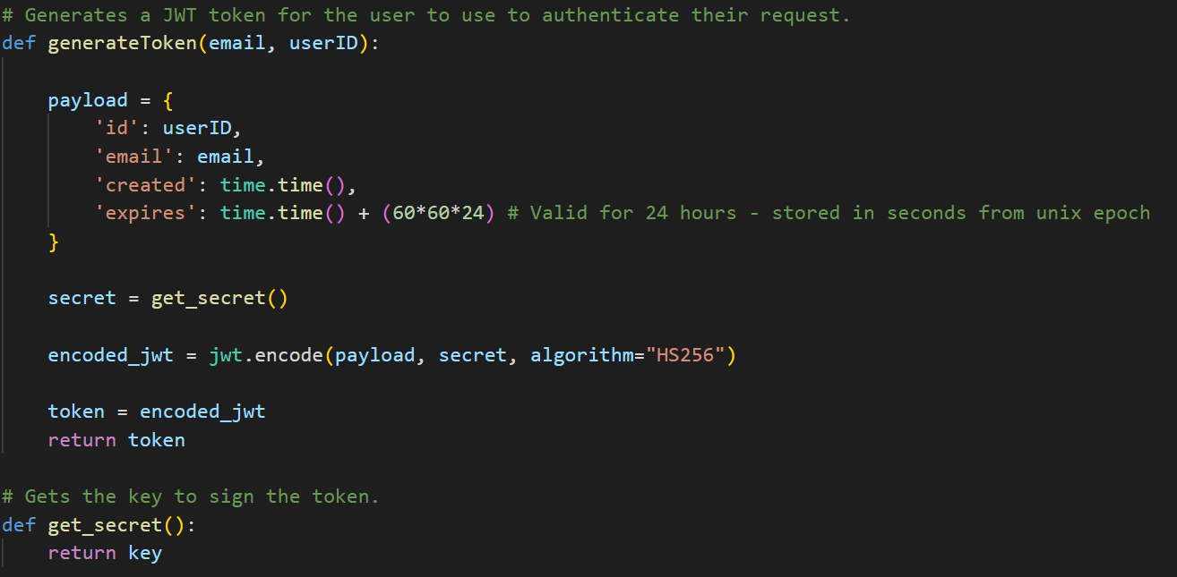

The last stage is for this JWT to be returned to the user and for the Flutter app to store it in secure storage so that it can be used to automatically login the user subsequent times the user logins until the token expires. The JWT is stored securely in the TokenStorage class using the FlutterSecureStorage package.

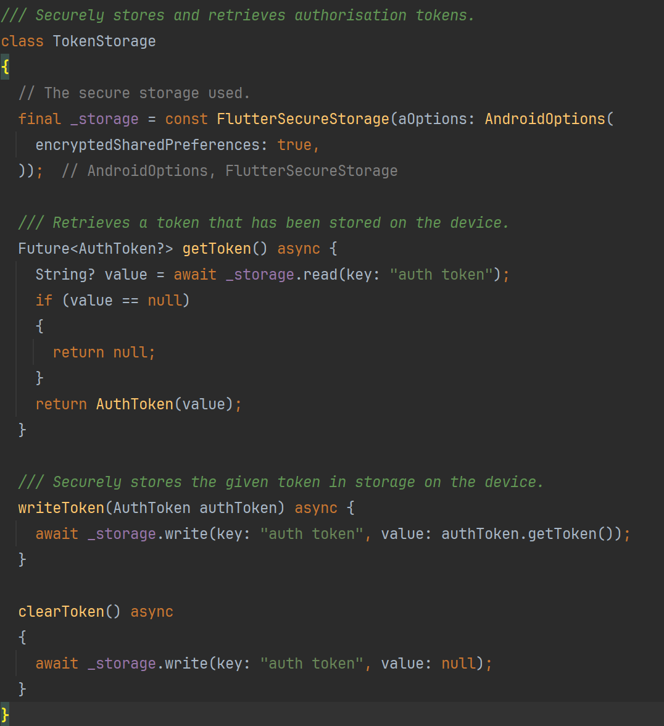

### Sprint 1 Summary

At the end of the first sprint, a Flutter app has been created with a login screen, a main screen with a working navigation bar, a map screen that displayed both a map and the user’s location. The server was also set up with a framework to easily add and call additional lambda methods and increase the capabilities of the database. This is a great jumping off point for the rest of the project and allows for the rest of work to be completed efficiently.

## Sprint 2 – Server-side API, Lambda Methods and Database Development

The goal of the second sprint was to develop the lambda methods and database to support the front-end that would be implemented later. The idea behind implementing all the lambda methods together instead of implementing a single method and then going and implementing the front-end for that feature, is that focusing on the lambda methods will keep them fresh in my mind and so allow me to work efficiently and effectively instead of having to refresh myself on how they work every time I want to implement a new method.

### Task 1 – Location Sharing

The first task is to implement the key feature of this project, location-sharing. This is done by having one lambda method which a user sends its location to, and a second lambda method which the user will get the other users locations from. These requests are done separately because the users location on the server should be updated every time the app receives an update of the users location, however, if the users location on the app isn’t getting frequent updates then if these requests were done together then the user wouldn’t get frequent updates on other users locations. This approach unties the user getting location updates of other users from their own location being updated.

The user’s location is updated on the server using the SetLocation lambda method. First the date is checked to see if it is a graduation day (8 am – 1 am next day), as location sharing is only enabled on graduation days. In reality this aspect was implemented at the end of development to make testing easier.

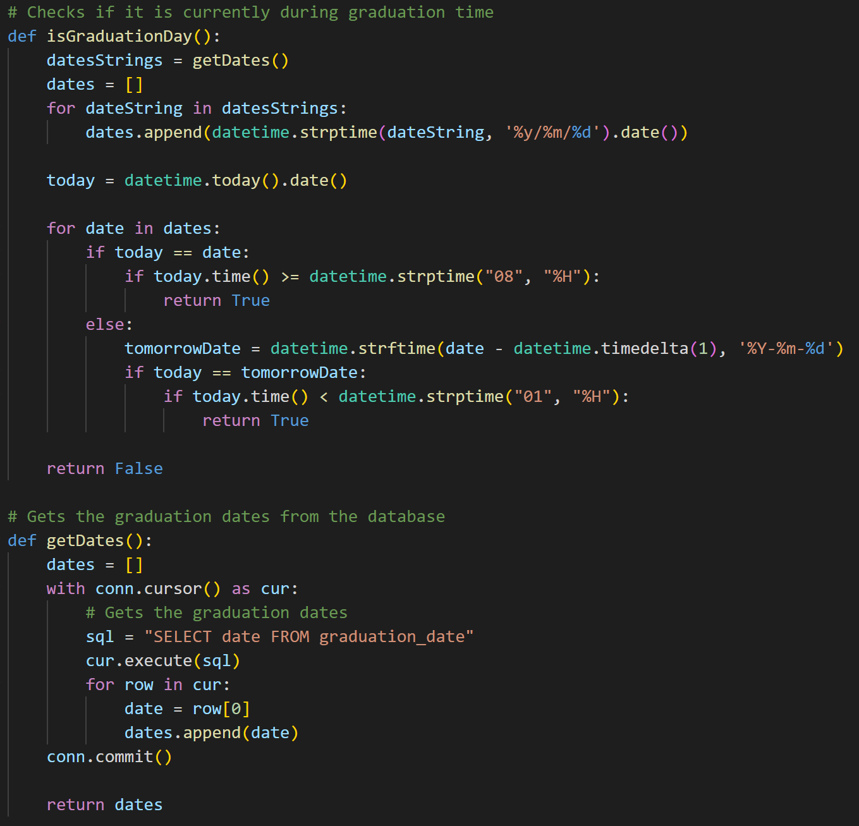

Then the location is simply inserted into the user’s entry using the userID taken from the JWT used to authenticate this request. The time that the location is set is also recorded so that once it is outdated information it isn’t sent out to users anymore.

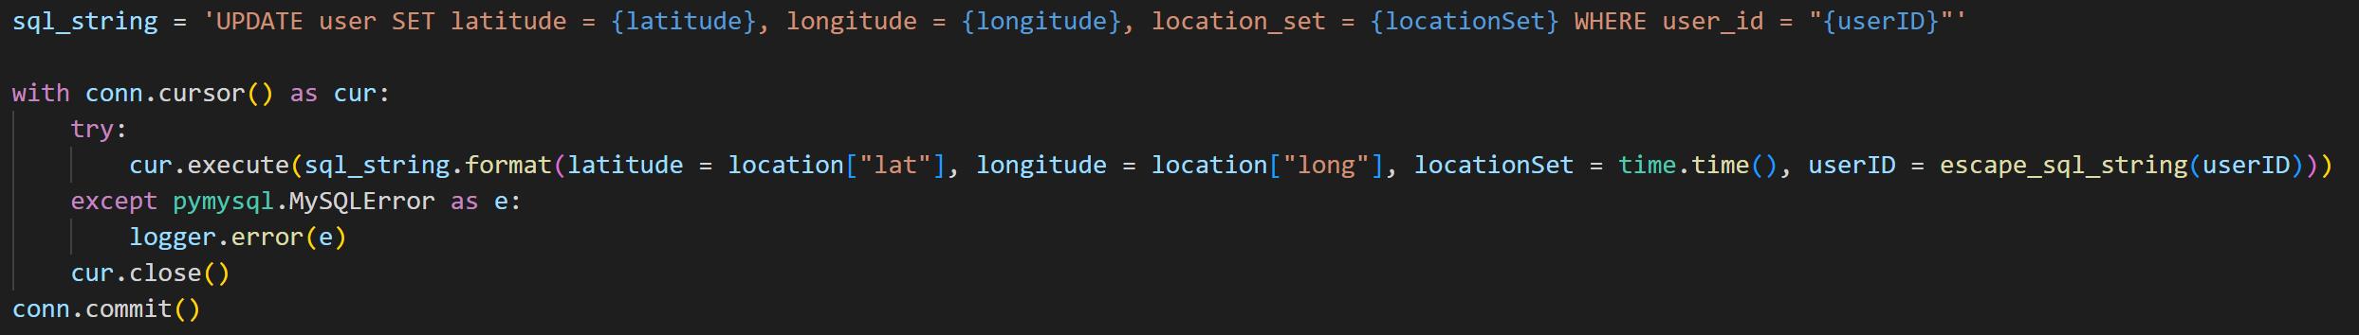

The locations of other users are retrieved using the GetOthersLocations lambda method. First it checks if it is graduation day, if so then it returns all the profile information and location of every user that this user has permission to see and that has set their location within the past minute.

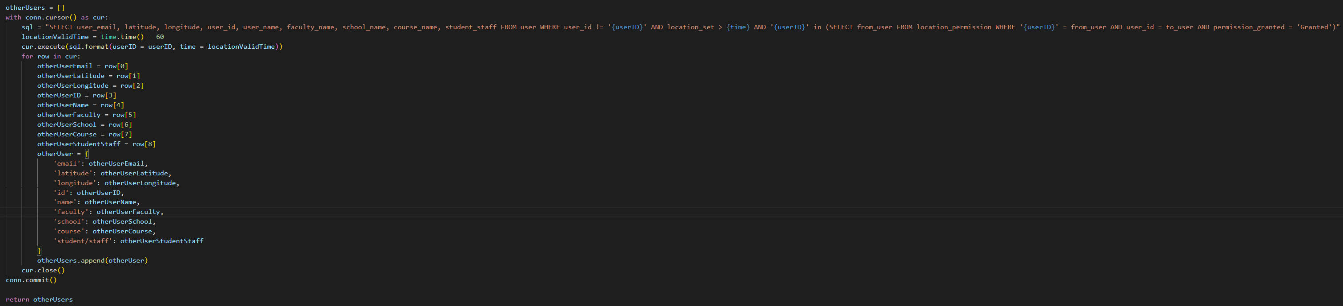

### Task 2 – Profiles

The second task was to store user profile information and allow it to be retrieved from other users. Users edit their own profile using the SetUserProfile and GetUserProfile lambda methods.

GetUserProfile is very simple, it just returns all the information on the user with the userID given by the JWT, this means that this information is only accessible to the user that the information is about.

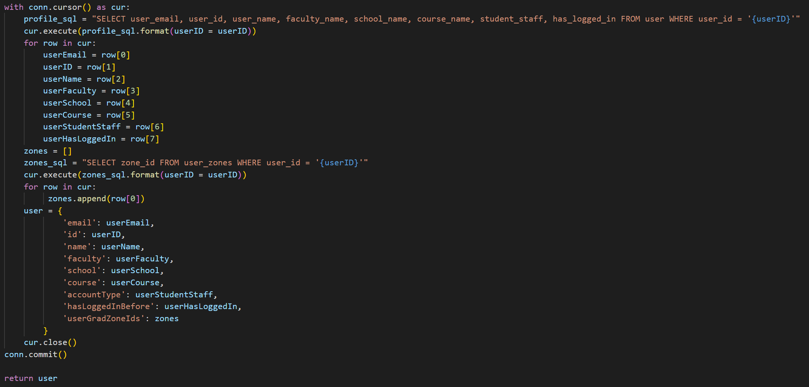

SetUserProfile allows a user to edit their own profile. It parses the input and sets any null data to “NULL”, then inserts it all into the database tables user and user_zones.

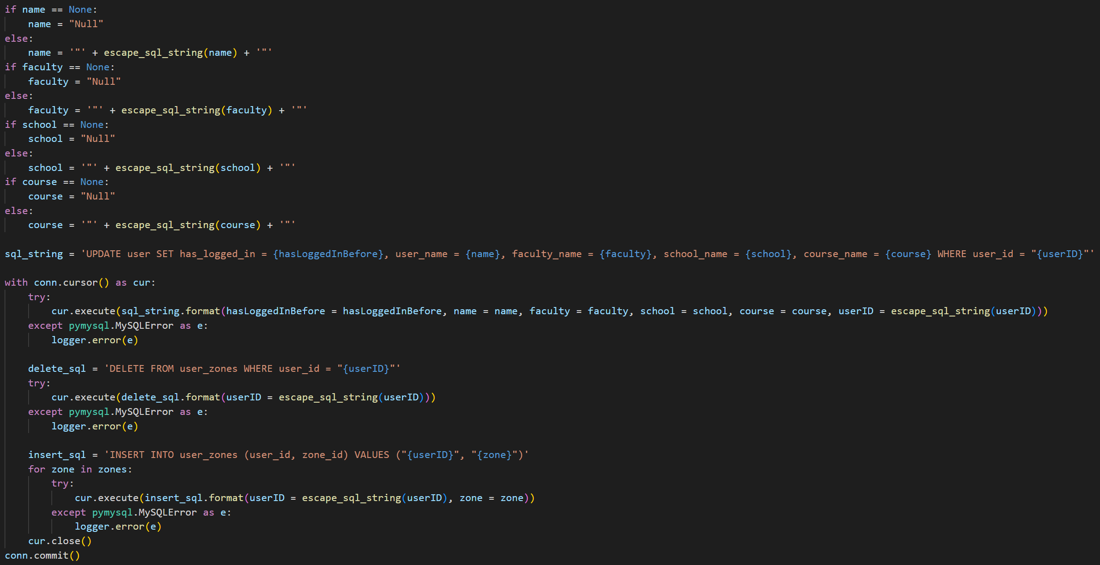

The methods allow the user to edit their faculty, school, course and graduation zones. However, at the moment there is no way for the user to retrieve the possible faculties, schools, courses and graduation zones.

The lambda method AcademicStructure gets the faculties, schools and courses.

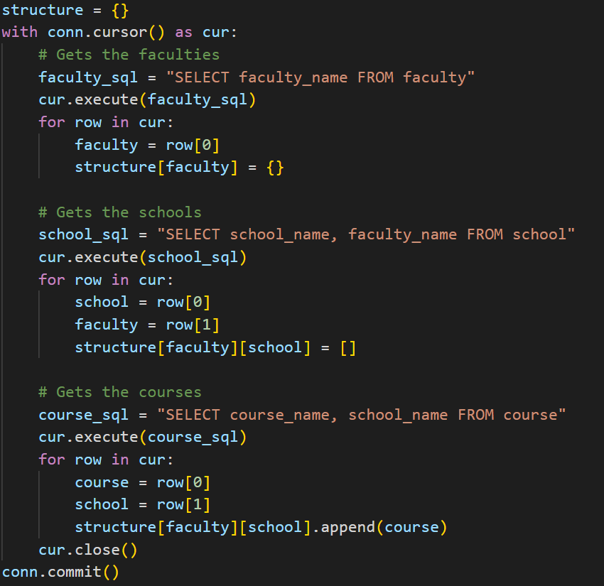

The lambda method GetGradZones returns the graduation zones. It gets the zones IDs, names and geojsons.

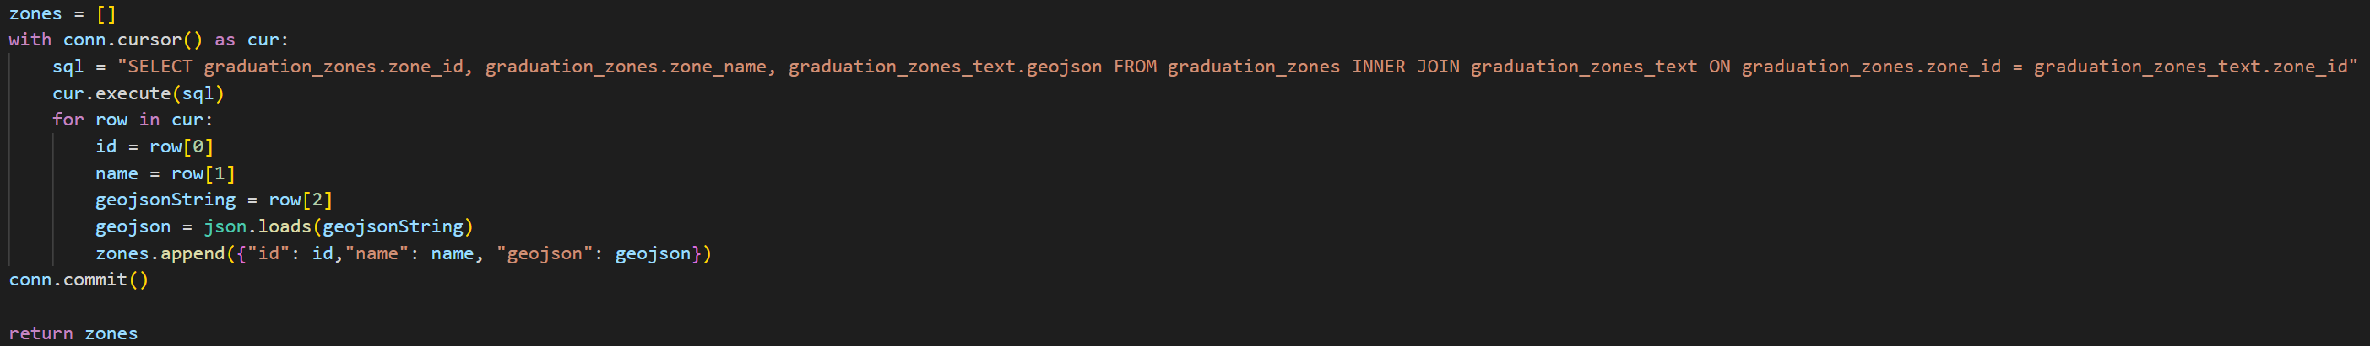

Finally, a user needs to be able to see the profiles of other users. This is done with the user of the lambda method GetAllOtherUsersProfiles which gets the user ID, email, name, faculty, school, course, and account type of every single other user that has verified their email address.

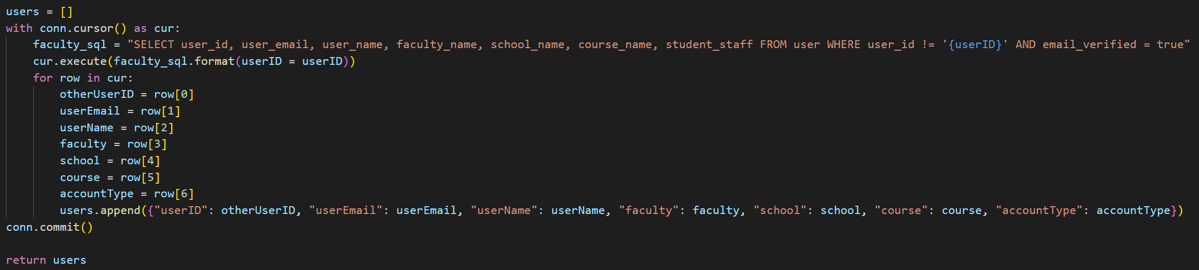

### Task 3 - Connections

The only part of the server now missing is the ability to request and grant permission to see other people’s locations. First, GetConnections returns all the connections that a given user has, this is both granted and requested permission, and both for this user to see other users and for other users to see this user.

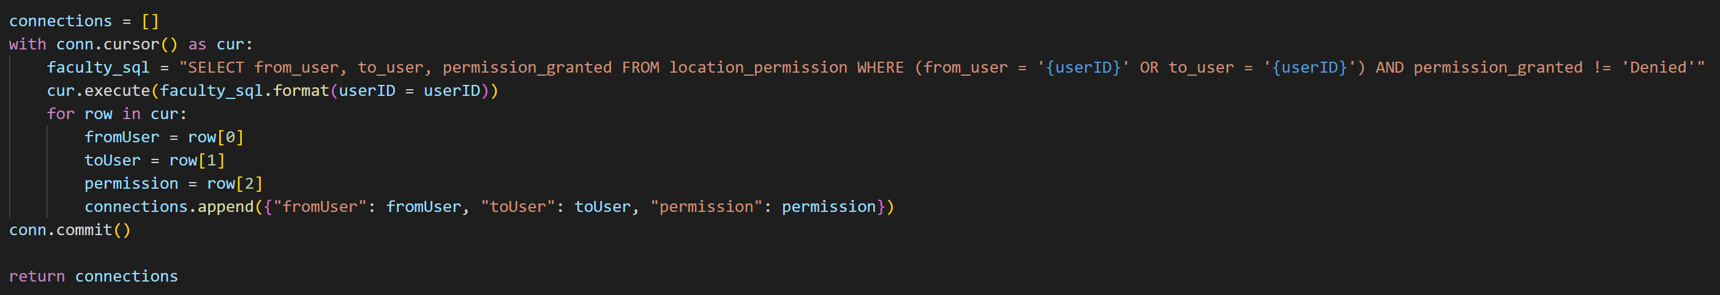

Finally we have the four lambda methods for managing connections:

SendConnectionRequest for requesting permission from another user to see them.

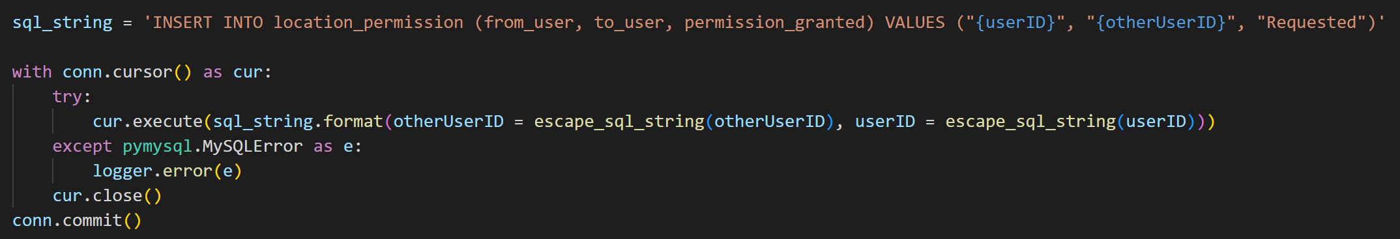

GrantFollowerRequest for granting permission to another user to see you.

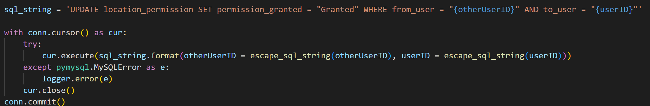

RemoveFollowingRequest for deleting your request for permission to see another user.

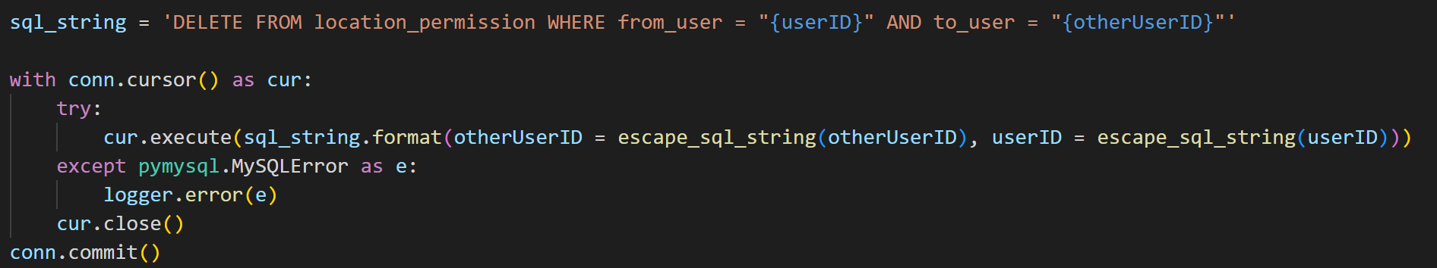

RemoveFollowerRequest for denying another user permission to see you.

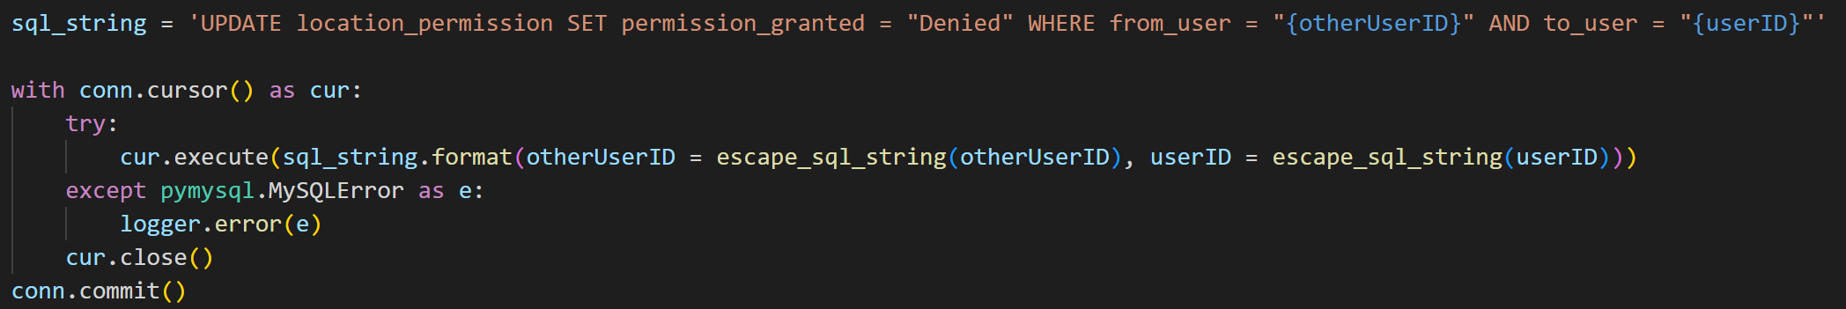

### Sprint 2 Summary

The server-side of the application is now in a near complete state, further editing would be done in later sprints as the design changes, but apart from these minor changes to server is done. Now the app itself can be built and focused on.

## Sprint 3 – UI and Front-end Logic

Sprint 3 is the final sprint, during which the UI and the logic to support it was built. This sprint provided a chance to evaluate the whole working product.

### Task 1 – Graduation Zones

The graduation zones are the areas of Portsmouth where a user’s location can be shared. A zone is coloured blue on a user’s map if they will appear within it, and red if they will not appear within it.

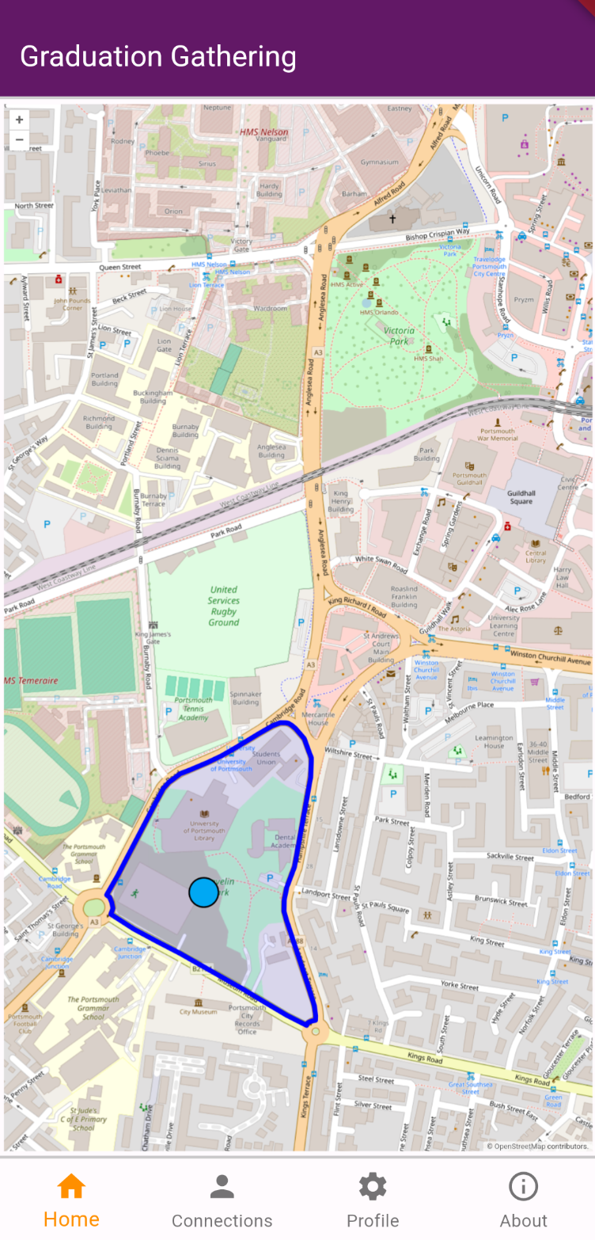 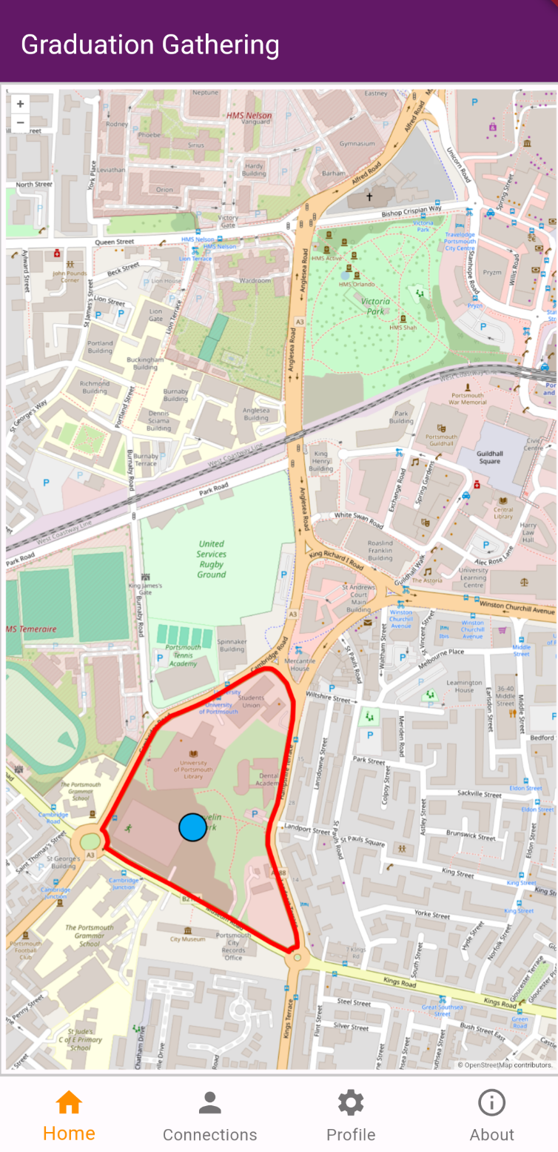

The zones are stored in the database as geojsons. These geojsons can then be directly given to OpenLayers to display on the map.

In Flutter these zones are stored in their own data structure, GradZones, which stores a set of GradZone. GradZone contains the zones id, name, geojson and colour in the form of the Colour enum.

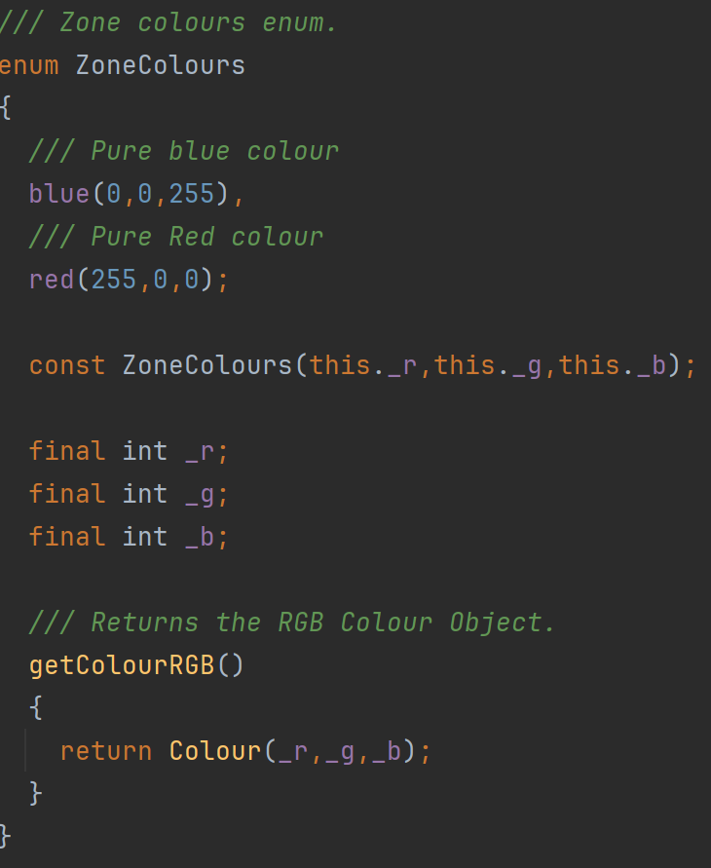

GradZones extends Iterable so that the zones can be easily looped through. GradZones also provides a method for the zones to be given as a sorted list by alphabetical order of their ID’s. This is to display on the profile screen. Sorting by alphabetical order of the ID’s will keep the order they are displayed consistent without actually ordering them by any meaningful characteristic.

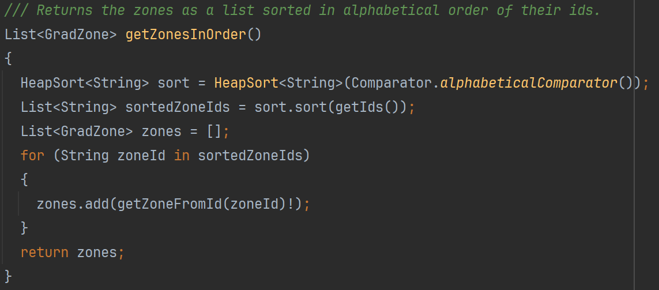

The sorting algorithm used is the heap sort as it is efficient for all input sizes and so it can be reused to sort larger datasets if needed.

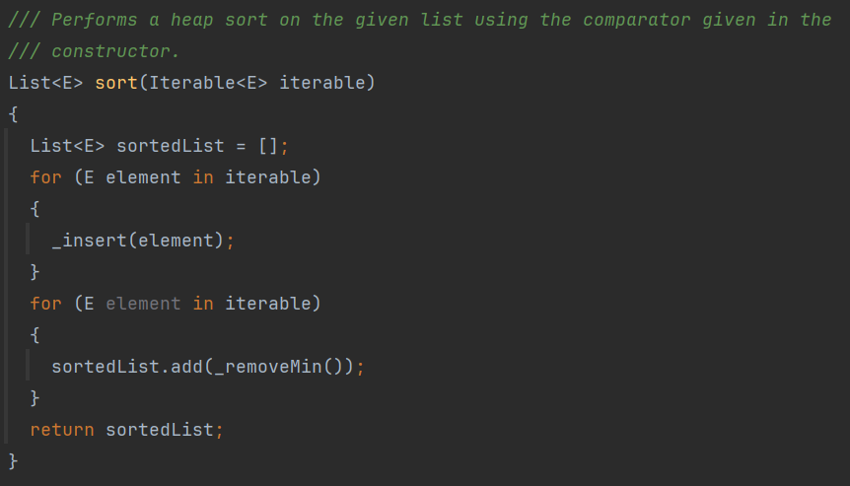

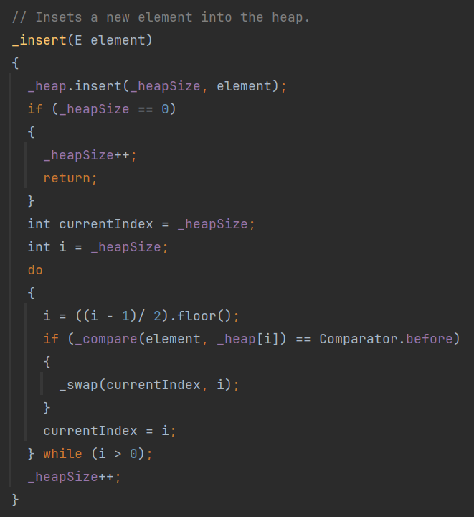

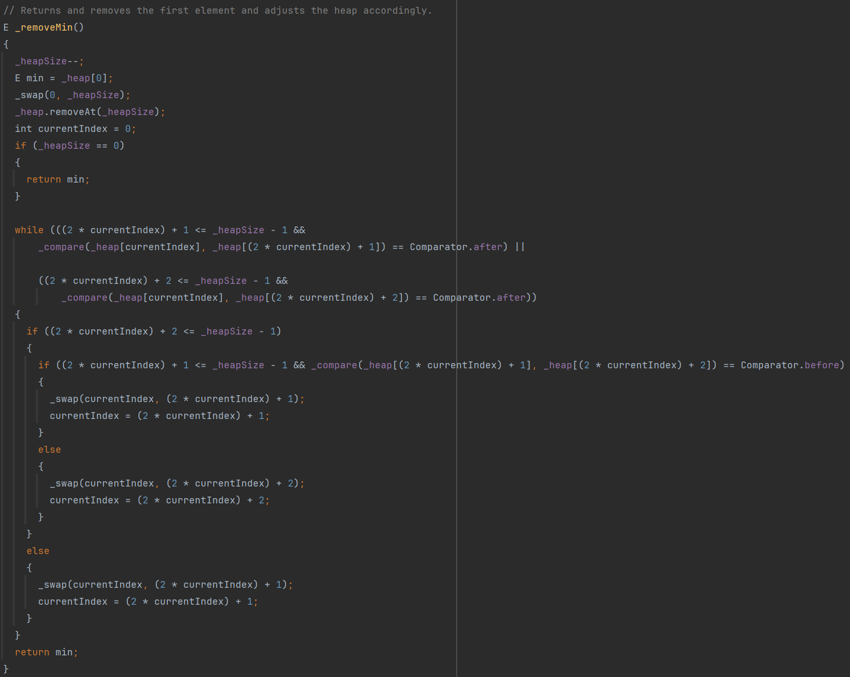

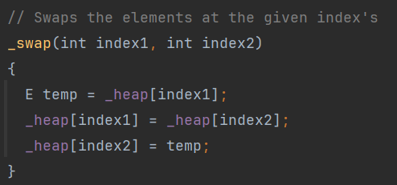

This heap sort also takes a comparator to sort the elements making it highly reusable.

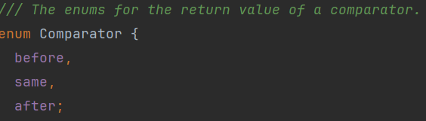

The comparator used to sort the zones is as follows:

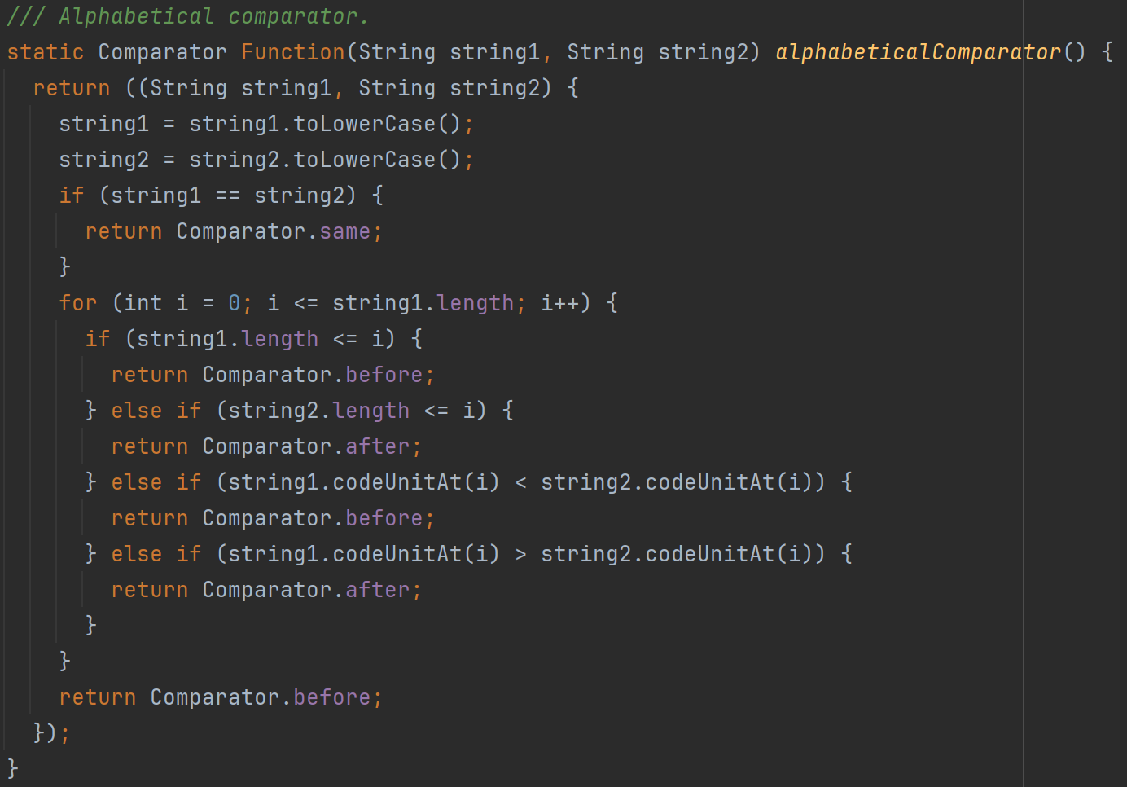

### Task 2 – Profile Screen

The profile screen allows a user to set their name, faculty, school, course, and finally which graduation zones they would like to appear in. The final design is as shown below.

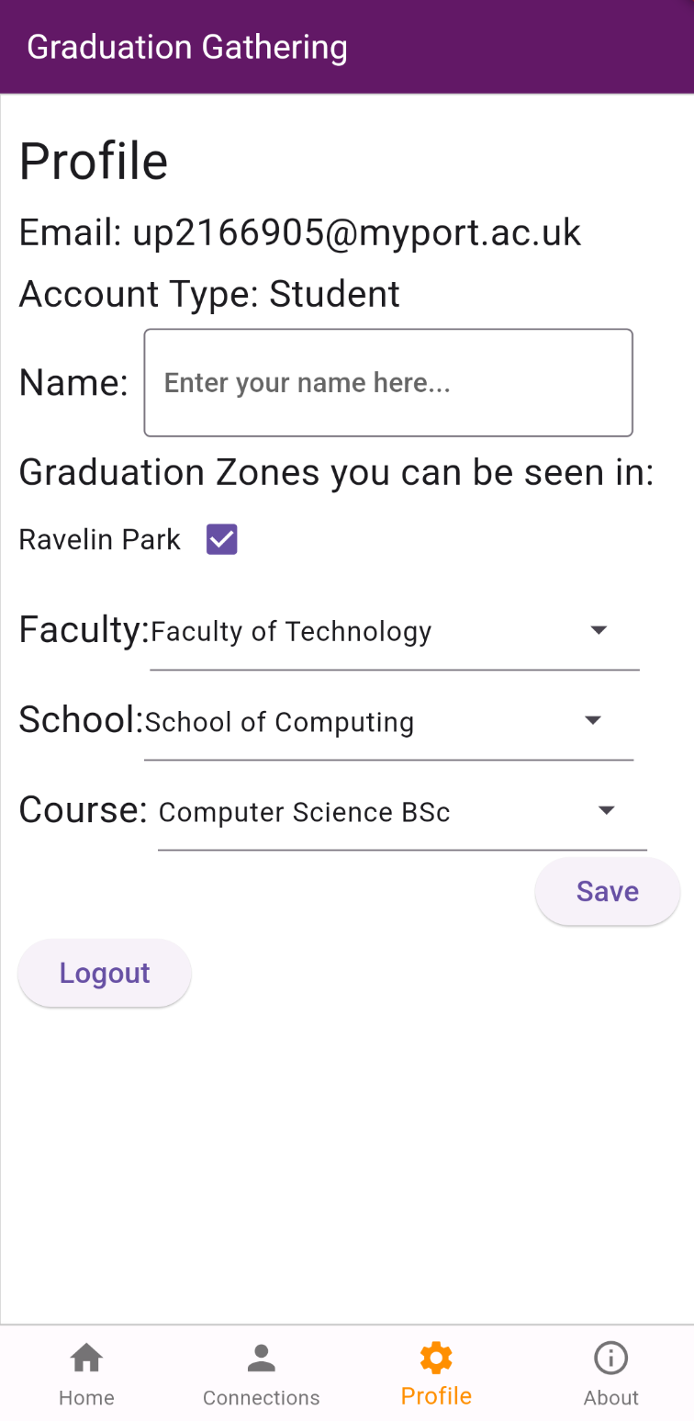

The faculties, schools and courses as seen from the profile screen are stored in the AcademicStructure class. This data structure stores the values in a Map<String, Map<String, Set<String>>>, in easier terms, it stores the values as a Map<Faculty, Map<School, Set<Course>>>. This allows for it to return all the faculties, all the schools, all the courses, all the schools in a faculty and all the courses in a school very efficiently and, for a data structure this small for importantly, the code to do so is very readable and editable.

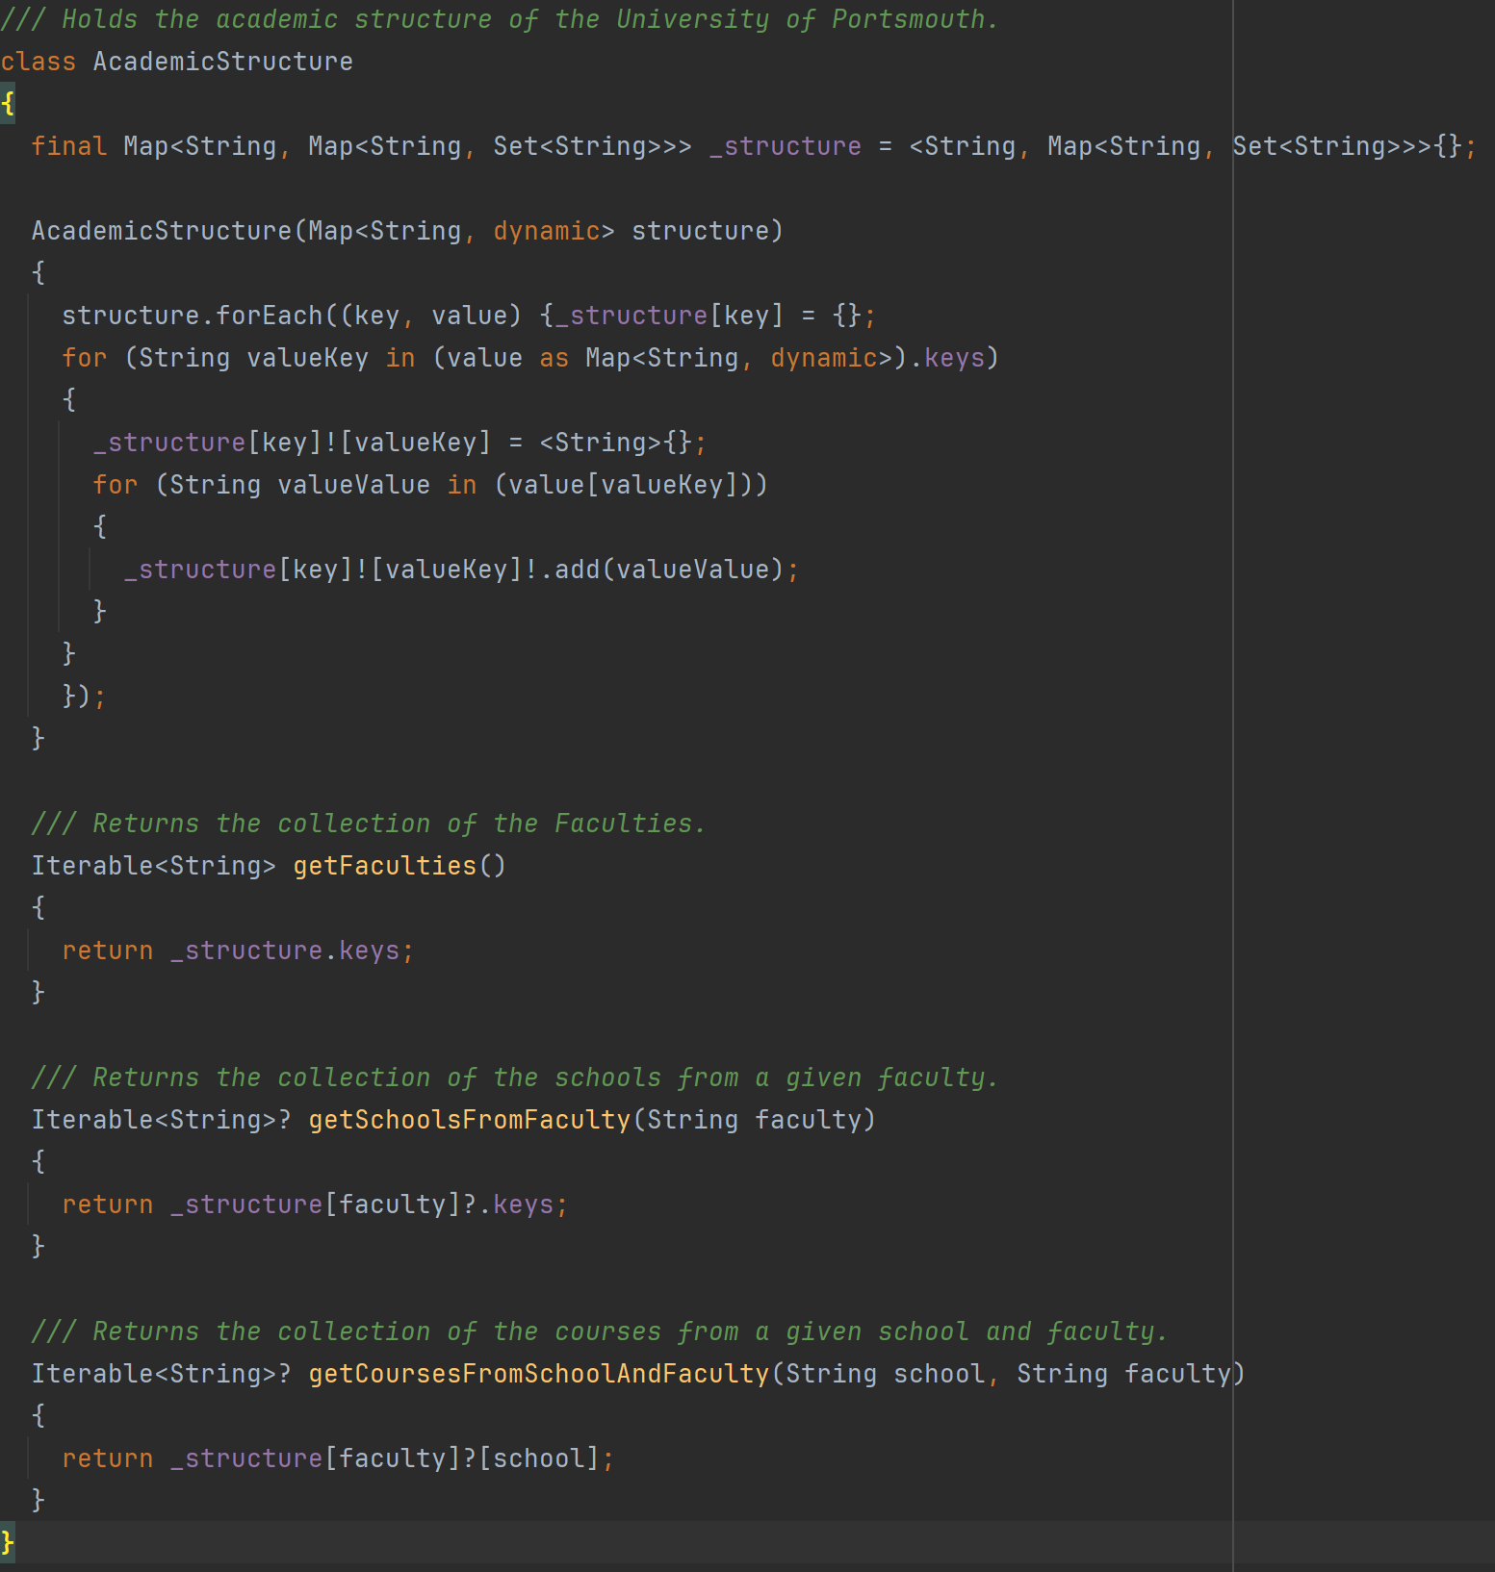

The account type of the user is also stored as an enum to simplify the code for when not to display courses to staff users.

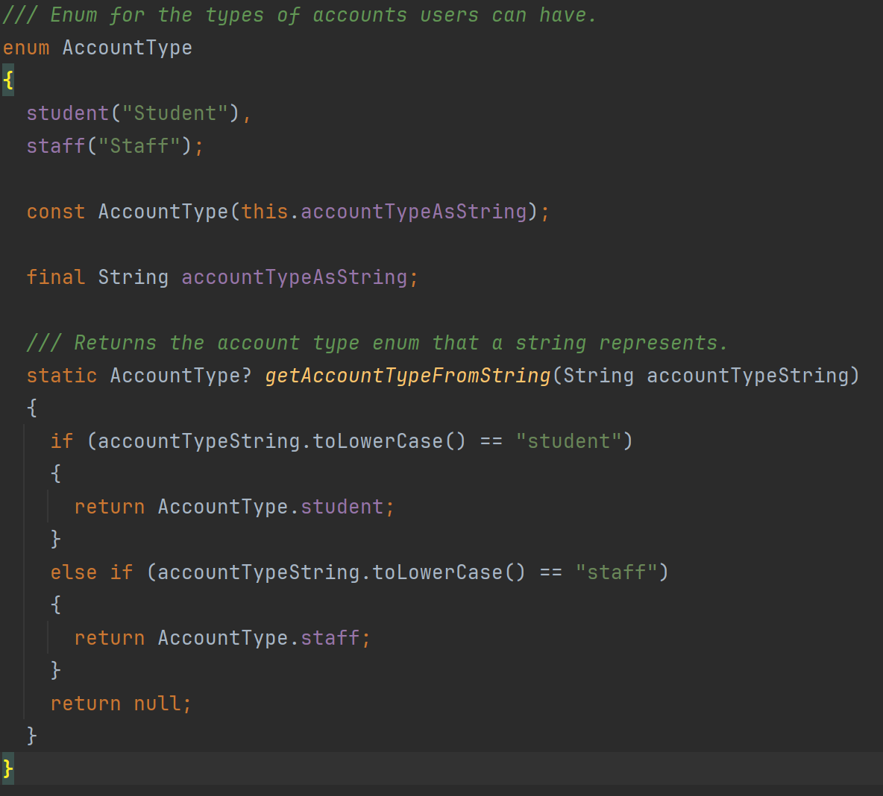

### Task 3 – Connections Screen

The connections screen has two parts, the first displays the connections you currently have, and the second allows you to request permission to see other users to connect with them.

Below is the connections screen when you have an incoming connection request, and then when you have one connection.

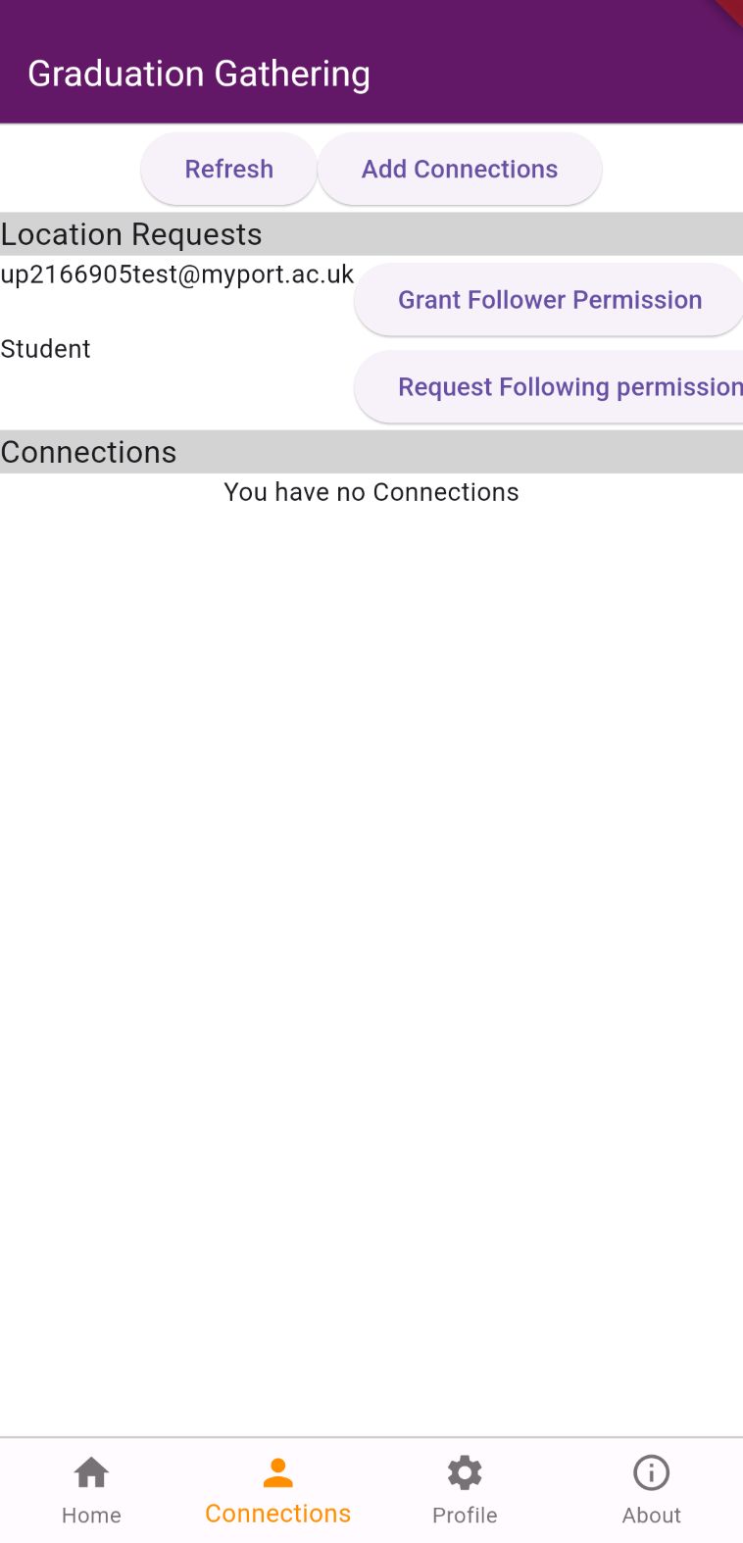 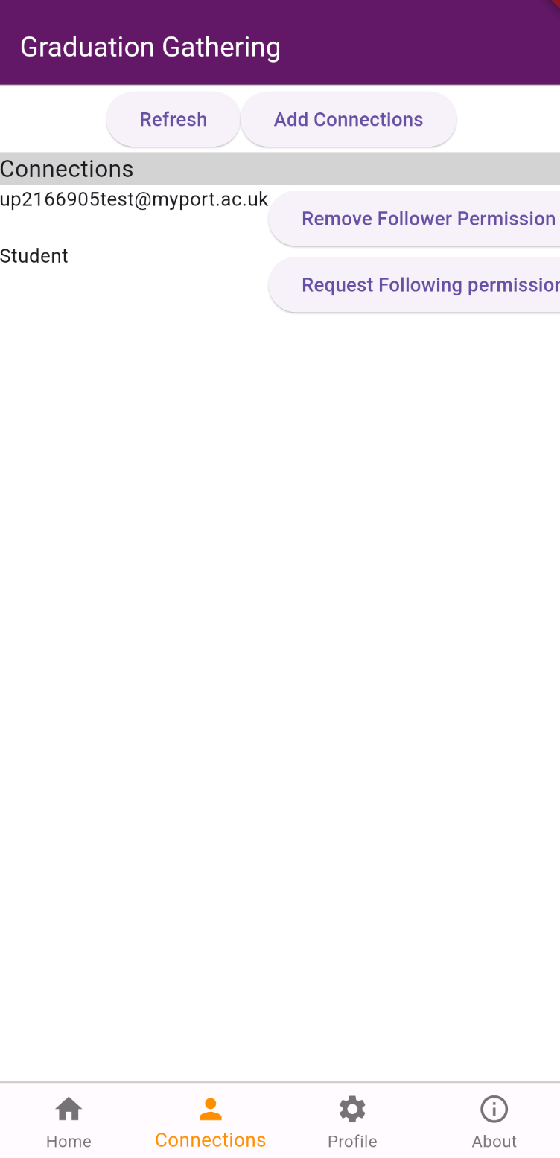

The following is the add connections screen when you are searching for a user.

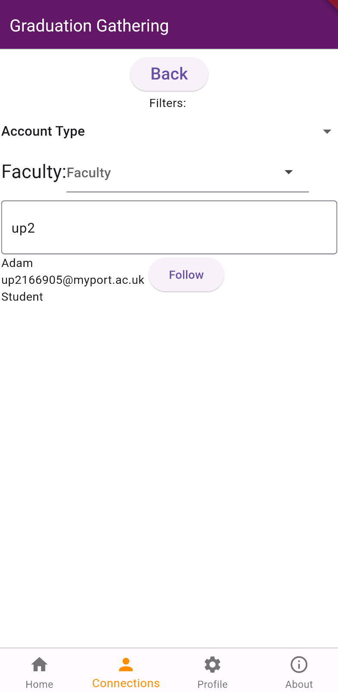

The connections are stored in the Connections class, which extends Iterable so that the connections can be easily looped through. They are parsed and transformed from the format User A, User B, permission (I.e. granted or request) into the format, User that is not this phone’s user, permission from this user to that user, permission to this user from that user. This parsing is done by the code below.

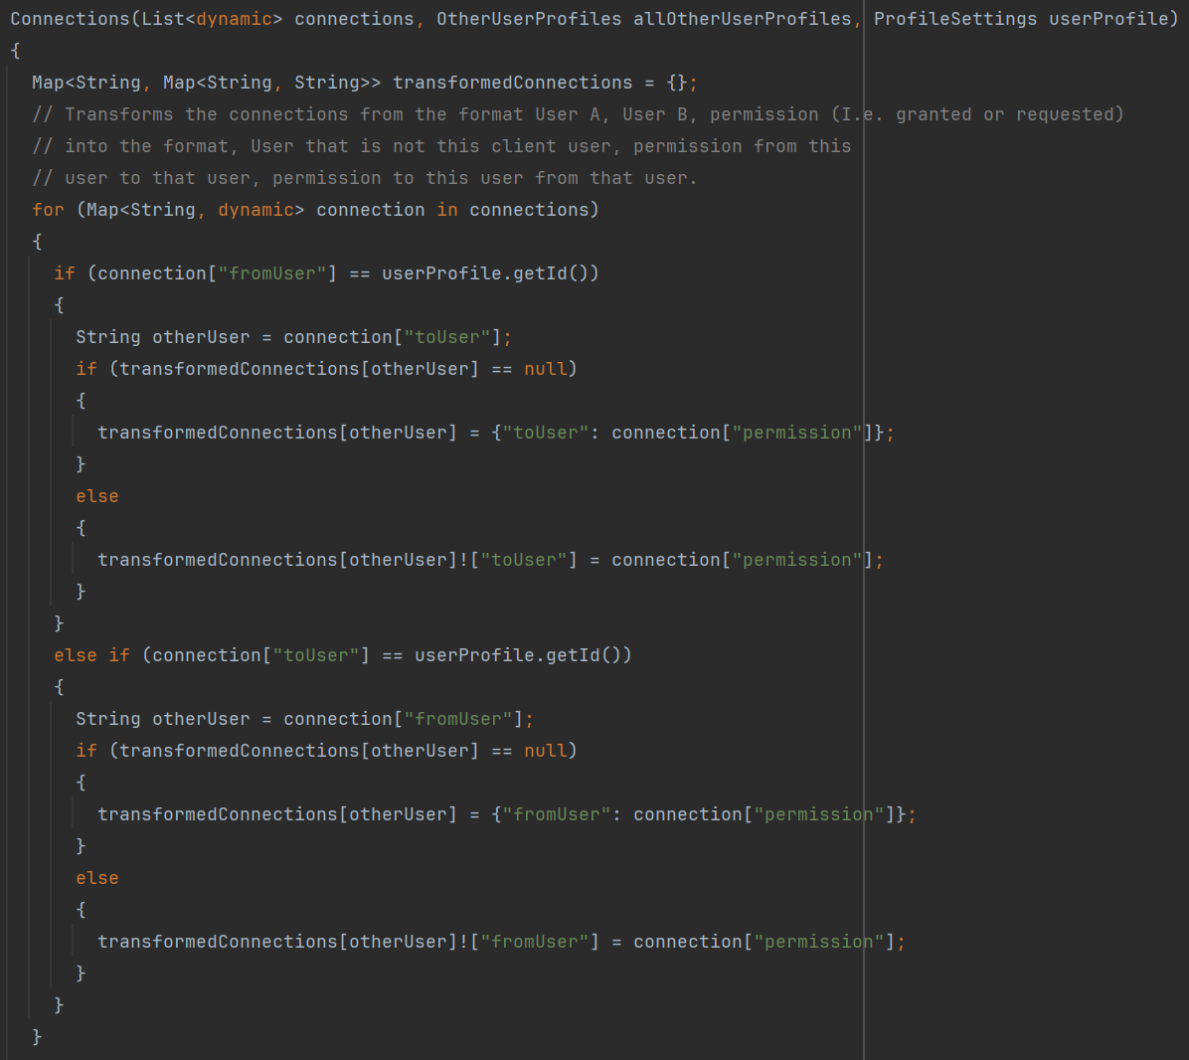

### Sprint 3 Summary

Graduation Gathering, from front-end to back, is now complete. Not all requirements have been met, but most have and the most important features have been added. This sprint has seen the UI being built and become responsive as well as the data needed to power the app being stored effectively in various data structures.

# Verification and Validation

Verification is checking that the software does what we expect it to do without having any bugs. Validation is checking that the software does what the requirements ask it to do.

For this project, at each stage of the implementation, I will first consider validation as it is pointless to test and debug only to realise afterwards that you built the wrong thing. I will think through the feature that I want to add, both before and after adding it, to ensure that it is what is required. Remember, the key goal for this project is to make it easier for students and staff to meetup on graduation day, so I must be convinced that a feature will help to do this in order to add this feature.

Once a feature has passed initial validation, I will then begin the implementation. In order to verify a feature it will undergo 2 sets of testing, manual debugging and automated unit testing. The server will also undergo load testing in order to verify it can handle the expected number of concurrent users.

## Manual Debugging

As I implemented every feature, I tested them extensively with a variety of inputs to verify that the software is acting as expected. This level of testing focused on the larger scale of the feature and so did not send specific inputs to the individual methods. However, this level of testing does include interacting with the UI and making sure that it reacts to user input appropriately, but also testing the server endpoints to make sure they return current data from the database. This level of testing uses the live server and not a mock of the methods and so could be unpredictable in exactly the results presented, however is reflective of how the app would be used and so gets a good perspective on the app. To be clear, this perspective is not as good as the feedback that would be given by actual users.

## Automated Unit Testing

For each public method implemented in the client side of the app, barring a few exceptions, unit tests have been written to automatically give the method a variety of inputs to check it returns the expected result. For this level of testing, mocks have been used to return data from the database and from local storage, this is to ensure consistency in the inputs to the test. Due to this reason any method that’s sole purpose is to retrieve data from the server unedited, has not had tests written for it as these tests would not accomplish anything. Unit testing is rigid and predictable and doesn’t reflect how actual users would interact with the program, however it does help you check you haven’t inadvertently broken an existing part of the program. The act of writing unit tests also makes you think about what the software is doing and how it accomplishes its task, this both helps with validation and verification. There have been many times when I have fixed a bug I didn’t know existed through writing unit tests, not through the output of the test being wrong, but through getting another perspective of the code written.

## Load Testing

In order to test if the server can support the desired number of concurrent users, I have designed a load testing experiment that can be run efficiently and repeated as the server is updated. I have written a poster on this experiment and the results that I got when I conducted the experiment. To summarise the findings of this experiment, here is a quote from the conclusion: “This performance evaluation has shown that the Graduation Gathering server functions properly up to 300 concurrent users and seamlessly up to 70 concurrent users when subjected to realistic test conditions. However, this is far from the 2000 concurrent users that the Graduation Gathering server is expected to handle.”

# Evaluation

The aim of this project was to create a location-sharing application to help students and staff of the University of Portsmouth connect on graduation day. In order to do this I have developed an app for both iOS and Android using Flutter with a server hosted on AWS. I have thoroughly tested each feature implemented to ensure it is bug free.

In this section I will evaluate my artefact against the requirements that I set out to implement. I will go through each requirement listed in the requirements section of this document and analyse whether it has been accomplished or not. I will then evaluate to what extent the aim of this project has been achieved based on the completed requirements.

In the tables of requirements below I have coloured in the rows of the completed requirements green, of the non-completed requirements red, any requirements where it is unknown whether it has been met shall be coloured orange, and finally any requirements where it has been partially met will be coloured blue and discussed further below.

## Functional

### Must Have

|  |  |
| --- | --- |
| ID | Description |
| 1 | A map that is rendered on screen showing Portsmouth |
| 2 | The user’s current location displayed on the map when the user has location enabled |
| 3 | The ability for other users current locations to be displayed on the map to the user |
| 4 | The ability to manage who has permission to see your current location |
| 5 | The ability to manage who you have permission to see their current location |
| 6 | Users login with their university emails (@myport.ac.uk and @port.ac.uk) by having a code sent to their email that they will then enter into the app |
| 7 | All requests sent to the server encrypted using HTTPS |
| 8 | All requests sent to the server once a user had logged in being authenticated using a JWT(Json web token) generated by the server when the user is logging in |
| 9 | Designated graduation zones to appear on the map, only in which will users locations be shared |

### Should Have

|  |  |
| --- | --- |
| ID | Description |
| 10 | Users locations only being shared on graduation days(8am – 2am the next day) |
| 11 | The ability for users to add their name to their account |
| 12 | The ability for users to add their faculty to their account |
| 13 | The ability for users to add their school to their account |
| 14 | The ability for users to add their course to their account |
| 15 | The account type (Student/Staff) saved to an account based on the email address that they used to login |
| 16 | The ability for users to select which graduation zones they must be in for their location to be shared |
| 17 | The ability to search for other users, when managing location permissions, by their email address |
| 18 | The ability to search for other users, when managing location permissions, by their name |
| 19 | The ability to search for other users, when managing location permissions, by their faculty |
| 20 | The ability to search for other users, when managing location permissions, by their school |
| 21 | The ability to search for other users, when managing location permissions, by their course |
| 22 | The ability to search for other users, when managing location permissions, by their account type |

### Could Have

|  |  |
| --- | --- |
| ID | Description |
| 23 | The ability to tap users you can see on your map to display the information they have added to their profile |
| 24 | The ability to tap users you can see on your map and tick a box to say you have already seen this person and so to stop that user from continuing to display on your map |
| 25 | The ability to filter the users that appear on your map by faculty |
| 26 | The ability to filter the users that appear on your map by school |
| 27 | The ability to filter the users that appear on your map by course |
| 28 | The ability to filter the users that appear on your map by email |
| 29 | The ability to filter the users that appear on your map by name |
| 30 | The ability to filter the users that appear on your map by graduation zones |
| 31 | The ability to filter the users that appear on your map by account type |
| 32 | A checklist of what students need to do on graduation day such as picking up their gown, attending their ceremony, going to the reception and collecting their certificate |
| 33 | Markers on the map showing the key locations for graduation (Guildhall, Ravelin Sports Centre, Gun House Green) |
| 34 | The above mentioned markers clickable to display information about what is happening at these locations |

## Non-Functional

### Must Have

|  |  |
| --- | --- |
| ID | Description |
| 40 | The ability to run on the latest version of Android(Android 14) |
| 41 | The ability to handle 50 concurrent users without denying any of them service(Returning Service Unavailable when a user’s client calls an endpoint on the server) |
| 42 | A users location update on other users devices at most 30 seconds after the users client get an update of its own location (assuming all users have a good connection to the internet) |
| 43 | The JWTs that are generated by the server for users to login be valid for 24 hours |
| 44 | The login codes sent to users emails should be valid for 5 minutes |

### Should Have

|  |  |
| --- | --- |
| ID | Description |
| 45 | The ability to run on the latest version of iOS(iOS 17) |
| 46 | The ability to handle 500 concurrent users without denying any of them service(Returning Service Unavailable when a user’s client calls an endpoint on the server) |

### Could Have

|  |  |
| --- | --- |
| ID | Description |
| 47 | The ability to handle 2000 concurrent users without denying any of them service(Returning Service Unavailable when a user’s client calls an endpoint on the server) |

As you can see from the above tables, all but one of the requirements I marked as a must have requirement, have been successfully implemented. Further, all of the functional should have requirements have also been implemented. However, none of the functional could have requirements have been met. For the non-functional requirements in the should have and could have categories, the server has failed to meet expectations and cannot handle the maximum expected number of concurrent users.

However, note that for requirement 45, this requirement has been marked as unknown as although the app has been built using Flutter and only contains packages that can be used on iOS, in order to actually compile and so test the software on iOS, you require an apple computer which I have been unable to acquire. Due to this the software most likely works on iOS but is completely untested and so this requirement cannot be verified.

For requirement 6, this has been partially met however does not fully work as intended. The system correctly only allows for accounts to be made using university emails. However, the server uses AWS Simple Email Service to send emails, and whilst the code I have written works currently to send the email, my AWS account is restricted to only being able to send emails to reverified email accounts. In other words, I can send emails to myself and only myself. I have looked into alternative email services however I do not believe any of them would allow me to use them.

## Conclusion

Graduation Gathering does successfully allow for seamless location sharing between up to 70 concurrent users on Android devices. It also does this securely encrypting and authenticating all requests made to the server. Users are also able to efficiently manage who they want to have permission to see them and who they have permission to see. Finally users are also able to customise their profile if they wish. This is a major success and should not be understated as this means that Graduation Gathering has achieved the goal it set out to achieve.

However, it lacks some quality of life features that would make it easier to use, such as being able to filter who displays on your map at a given time and being able to tap users on the map to see who they are.

Graduation Gathering’s UI is also not the prettiest, this is not something that can be judged by requirements. Whilst it does stick to a nice colour scheme based off of the University of Portsmouth’s colour, the look of the buttons and text is not the nicest in places.

Finally, the server does not meet expectations. It does allow for the must have required 50 concurrent users which does make the app usable under its current state. However, if Graduation Gathering were ever to be rolled out to actually be used and endorsed by the graduation team at the University of Portsmouth, it would need to be far more capable than it currently is.

Overall, this project is a success, however too many requirements were taken on for the time frame given. The main problem was unforeseen events affecting production far more than I anticipated.

# Conclusions and Future Work